Determination of Soil Stiffness Parameters

Computational Geotechnics

Contents

General concepts and stiffness of sand

Hooke’s law
E-moduli from triaxial testing
E-moduli from oedometer testing
Examples on the estimation of E

Stiffness of clays

Undrained clay behavior
Drained clay behavior
Examples on the estimation of E
Idealized and real stress-strain behavior of soils

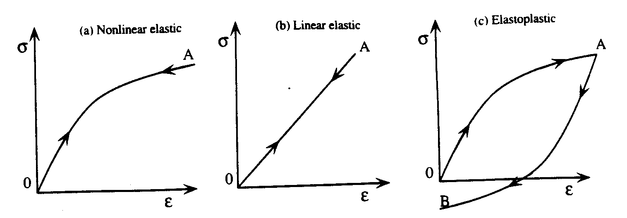
Idealized types of stress-strain behaviors: (a) nonlinear elastic model. (b) linear elastic model, and (c) elastoplastic model

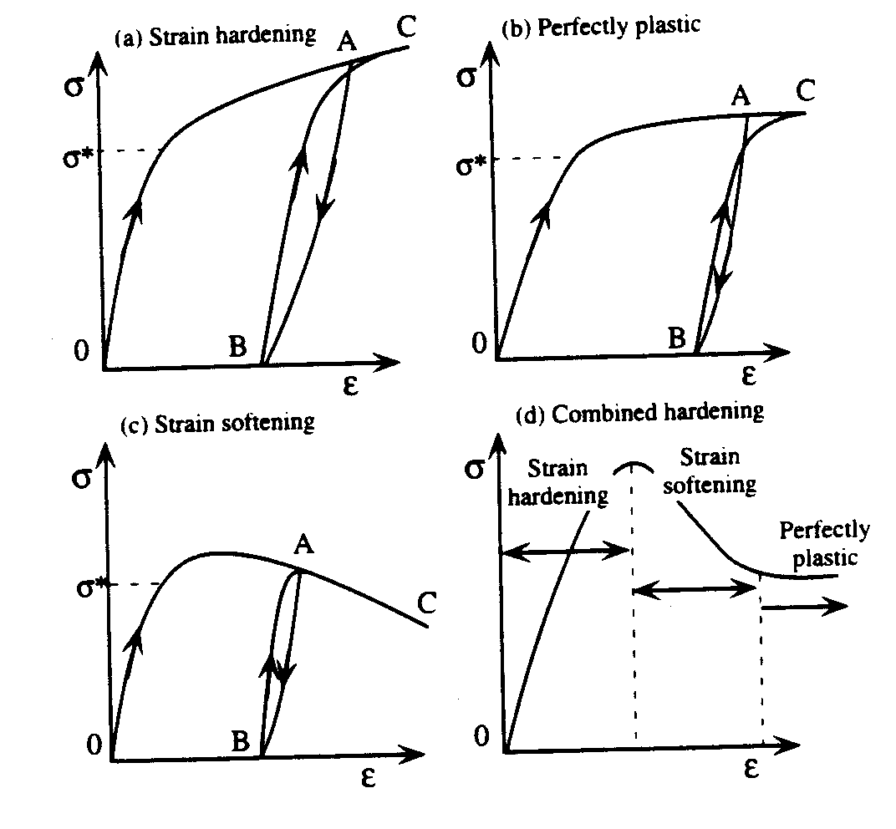
Various types of elastoplastic behaviors: (a) strain hardening, (b) perfectly plastic, (c) strain softening, and (d) combination of a to c.

(Bardet, 2000)
Hooke’s Law of Isotropic Elasticity

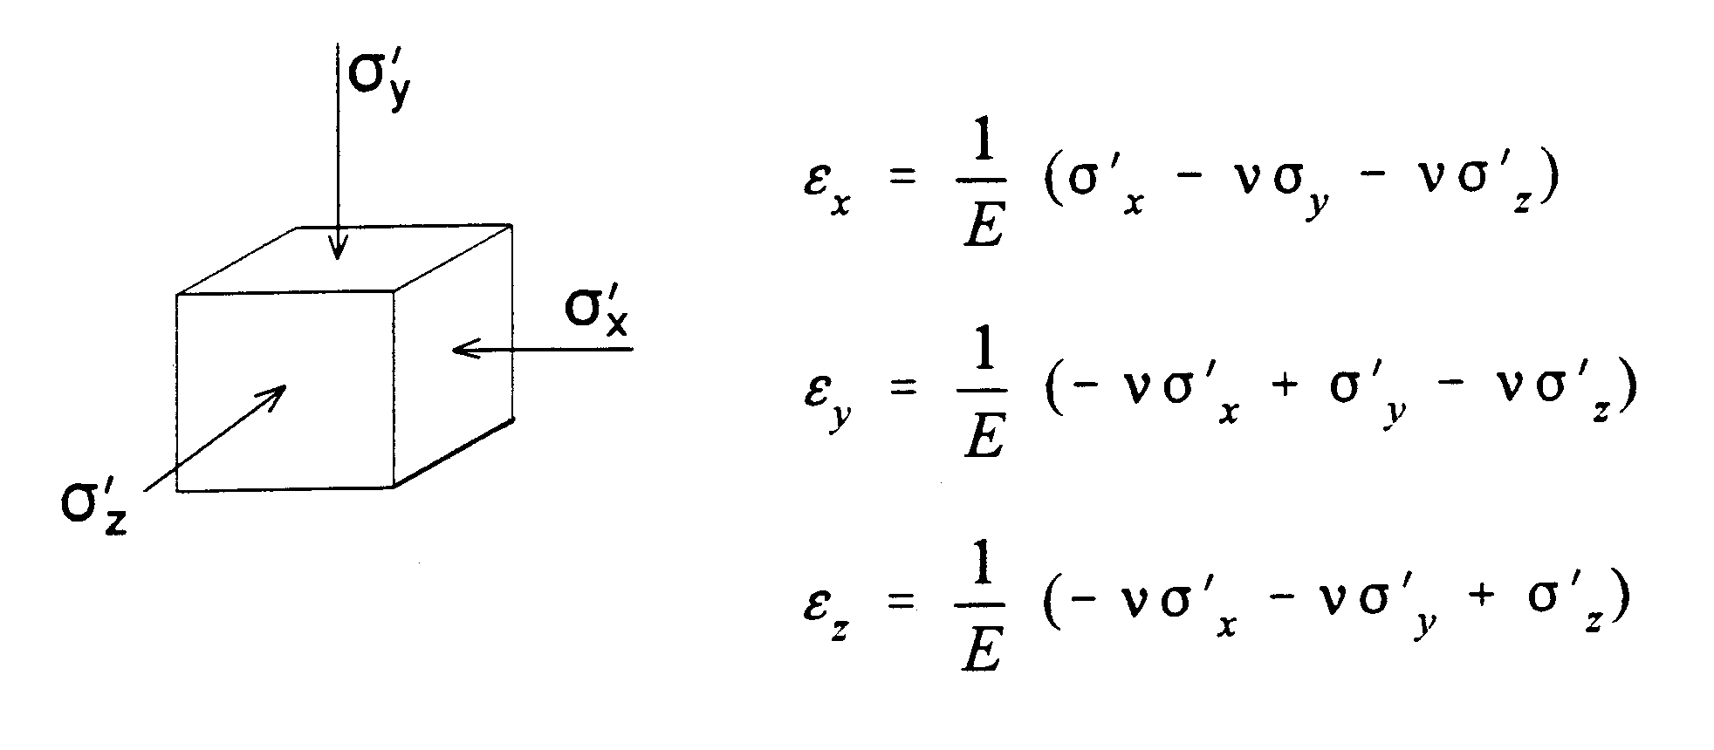
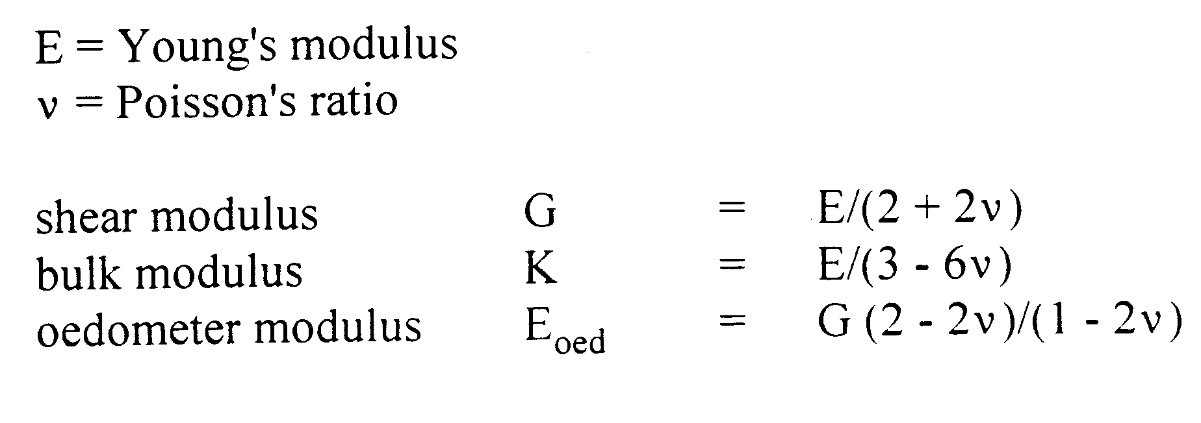
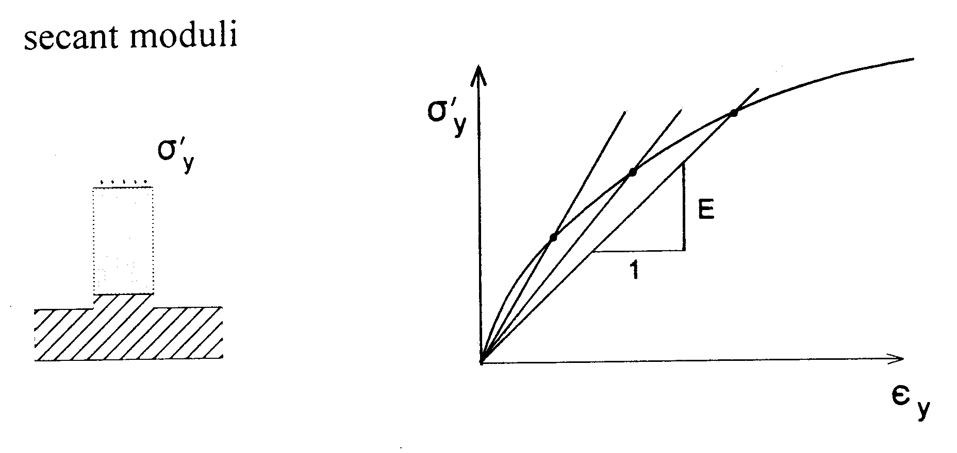
Standard Drained Triaxial Test on Sand

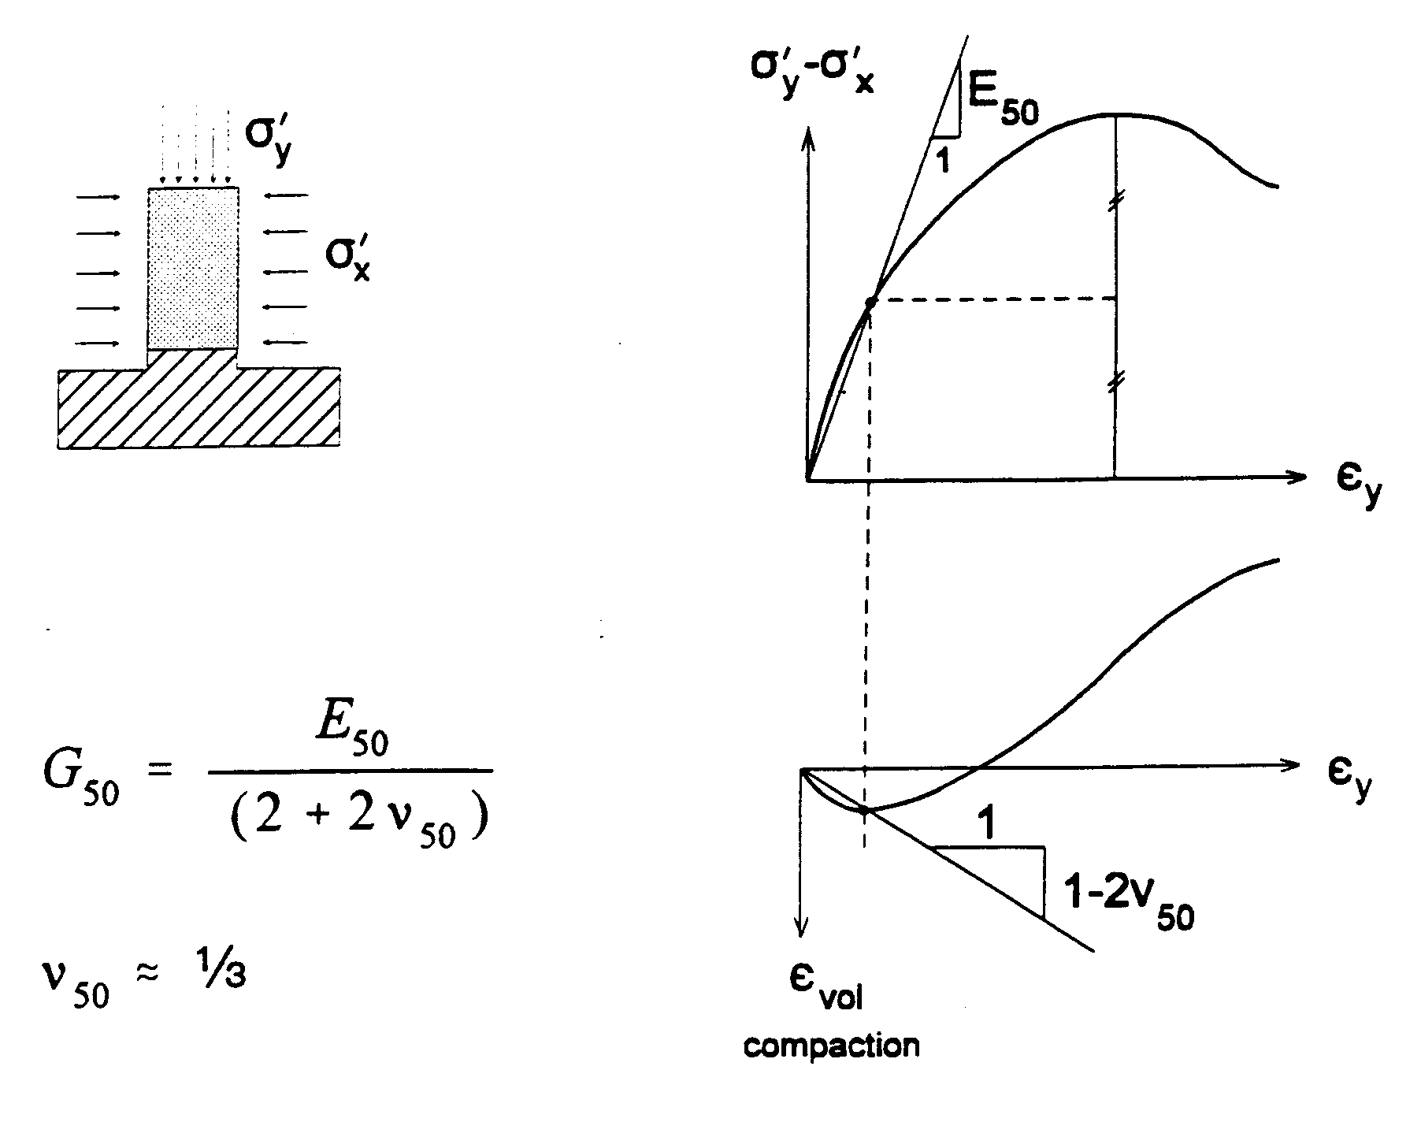

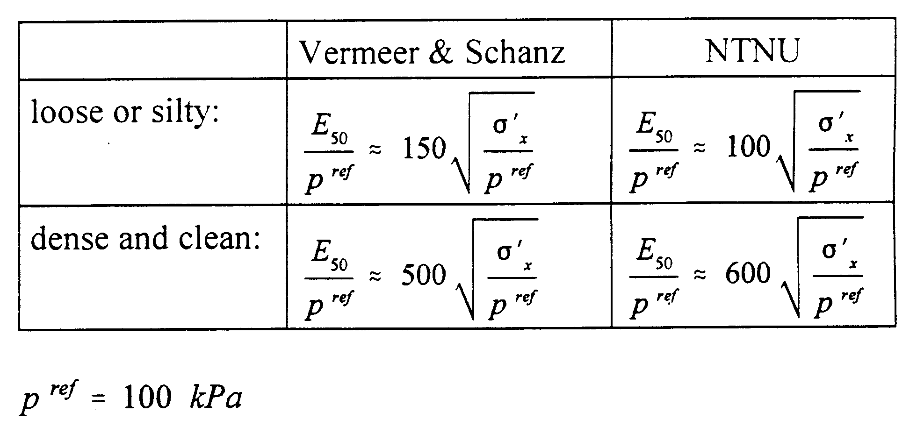
Oedometer Test on Sand

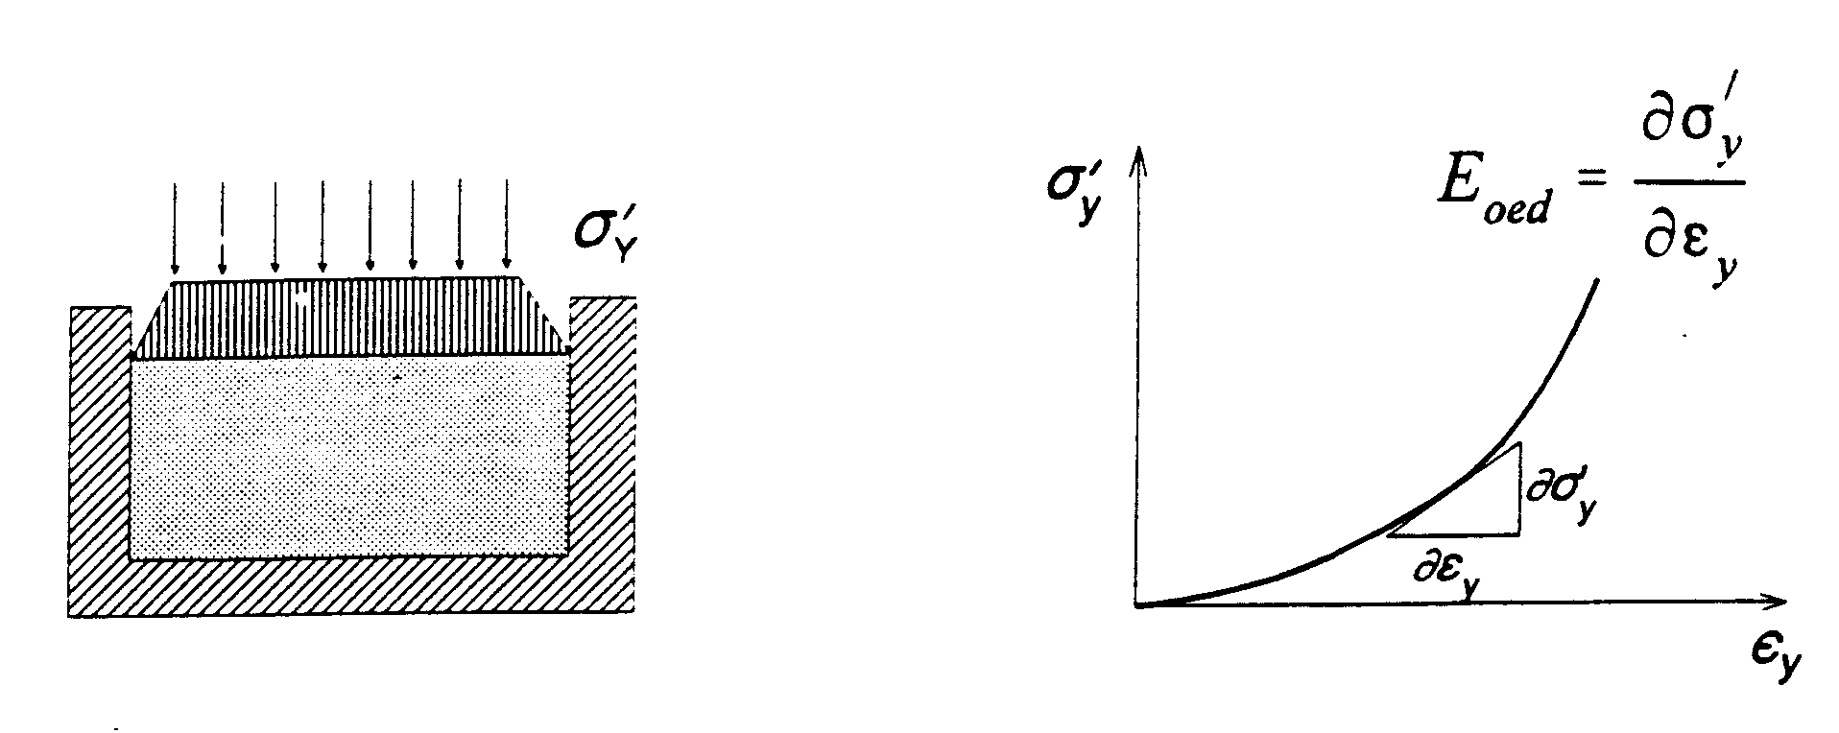

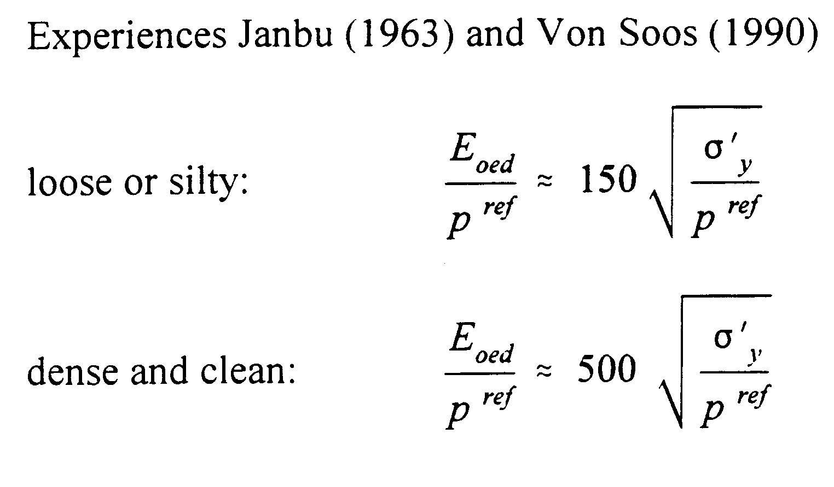
Oedometer Test on Sand

Hooke:
Loose: | $$\frac{E}{p^{\text{ref}}}≈\text{150}×\frac{2}{3}\sqrt{\frac{σ_{y}}{p^{\text{ref}}}}$$
Dense: | $$\frac{E}{p^{\text{ref}}}≈\text{500}×\frac{2}{3}\sqrt{\frac{σ_{y}}{p^{\text{ref}}}}$$

Loose: | $$\frac{E}{p^{\text{ref}}}≈\text{150}×\frac{2}{3}\sqrt{2}\sqrt{\frac{σ_{x}}{p^{\text{ref}}}}≈\text{150}\sqrt{\frac{σ_{x}}{p^{\text{ref}}}}$$
Dense: | $$\frac{E}{p^{\text{ref}}}≈\text{500}×\frac{2}{3}\sqrt{2}\sqrt{\frac{σ_{x}}{p^{\text{ref}}}}≈\text{500}\sqrt{\frac{σ_{x}}{p^{\text{ref}}}}$$

This implies:

Summary on Stiffness Parameters: Sand

(Laboratory based experience)

Loose:
Dense:
Loose:
Dense:

Unloading: About 4 times stiffer. ν small
Selection of Moduli for FEM-Computation

Examples 1 (loading):

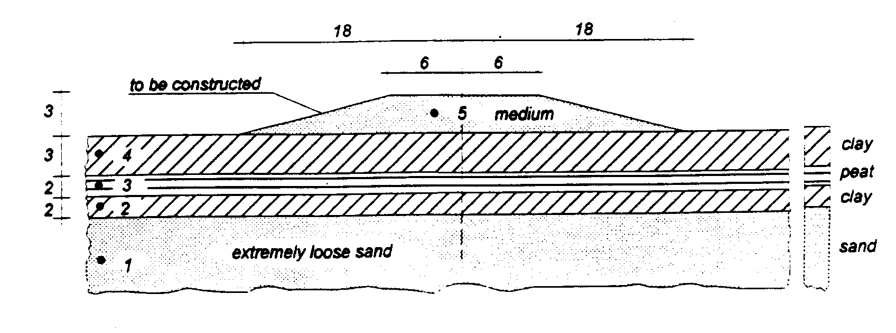

Layer 1 (extremely loose sand):

Mohr-Coulomb model:
Layer 1:
Average:

Selection of Moduli for FEM-Computation

Examples 2 (unloading):

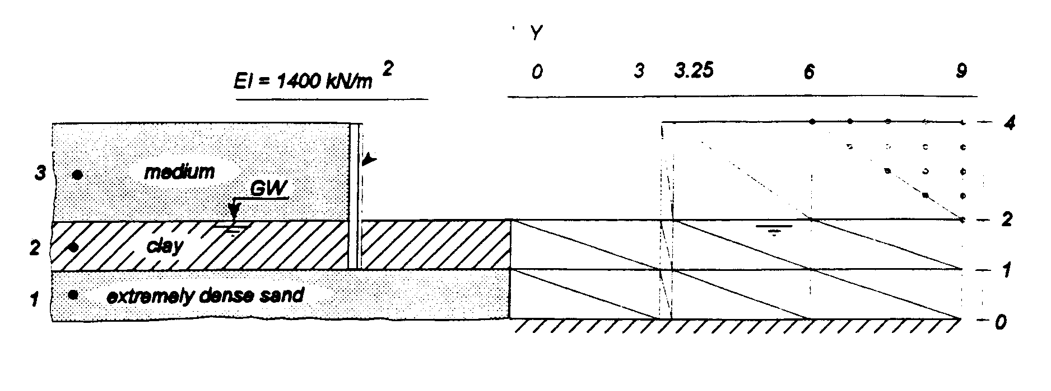

Layer 1 (dense):
Layer 3 (medium):
Unloading: $E_{\text{ur}}^{\text{ref}}≈4E_{\text{50}}^{\text{ref}},ν≈0\text{.}\text{15}$for both layers
Mohr-Coulomb model:

Layer 1:
Layer 3: | $E=4×\text{30000}\sqrt{0\text{.}\text{10}}≈\text{38000}\text{kPa}$

E_{oed} from Cone Penetration Test in Sands

Cone Resistance | :
Correlation | :
Literature NC-sand | : |  | to 3
Vermeer’s experience | :
Alternatively | : | $$E_{\text{oed}}=(\text{30}±\text{10})\sqrt{q_{c}p^{\text{ref}}}$$

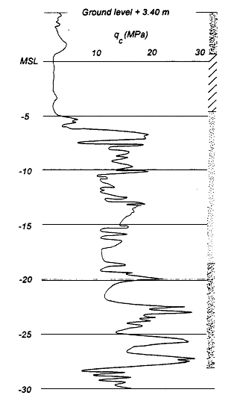
Undrained Triaxial Test on Clay

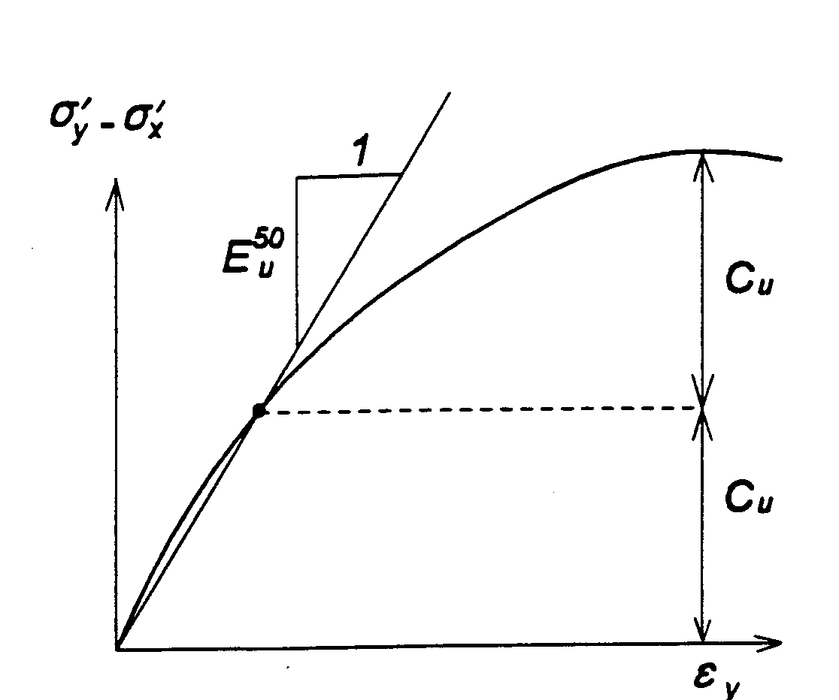

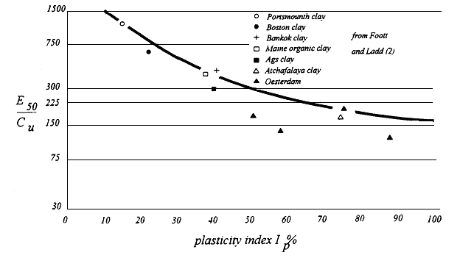

Normally consolidated clay:
C_{u} = undrained shear strength (or S_{u})
Idealized and real stress-strain behavior of soils
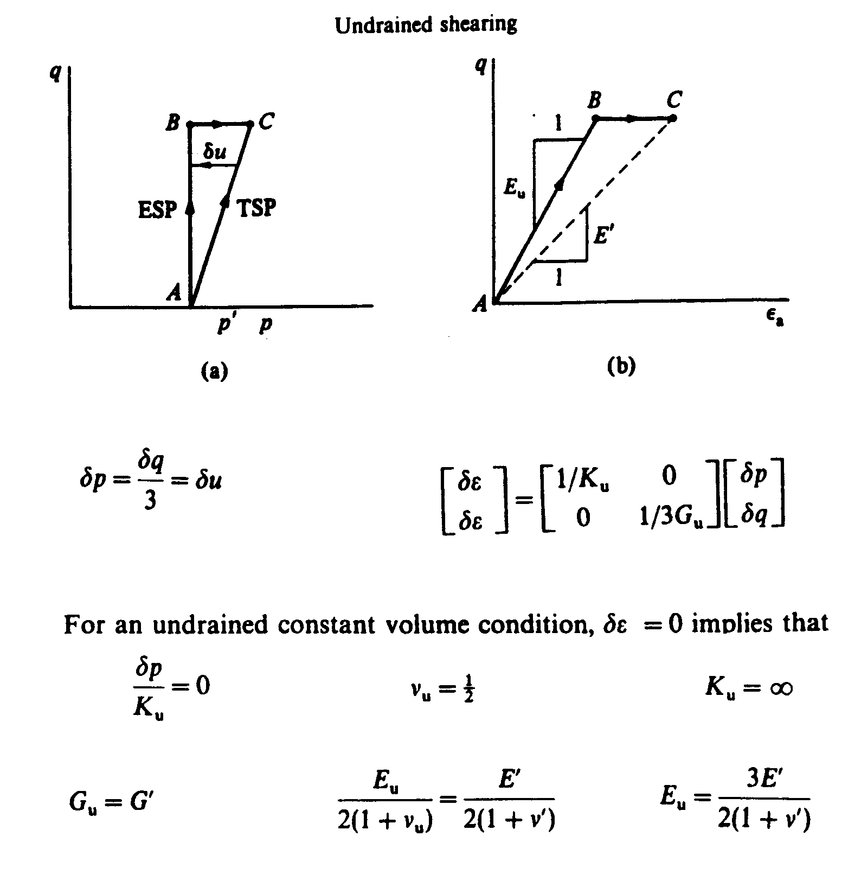
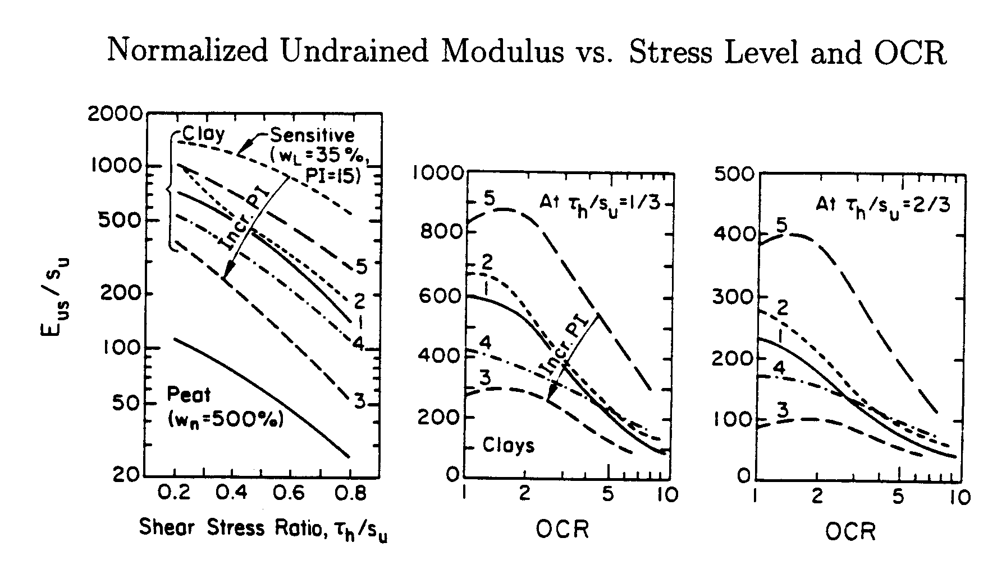
(Ladd et al., 1977)
Plate Loading Tests by Duncan & Buchignani (1976)

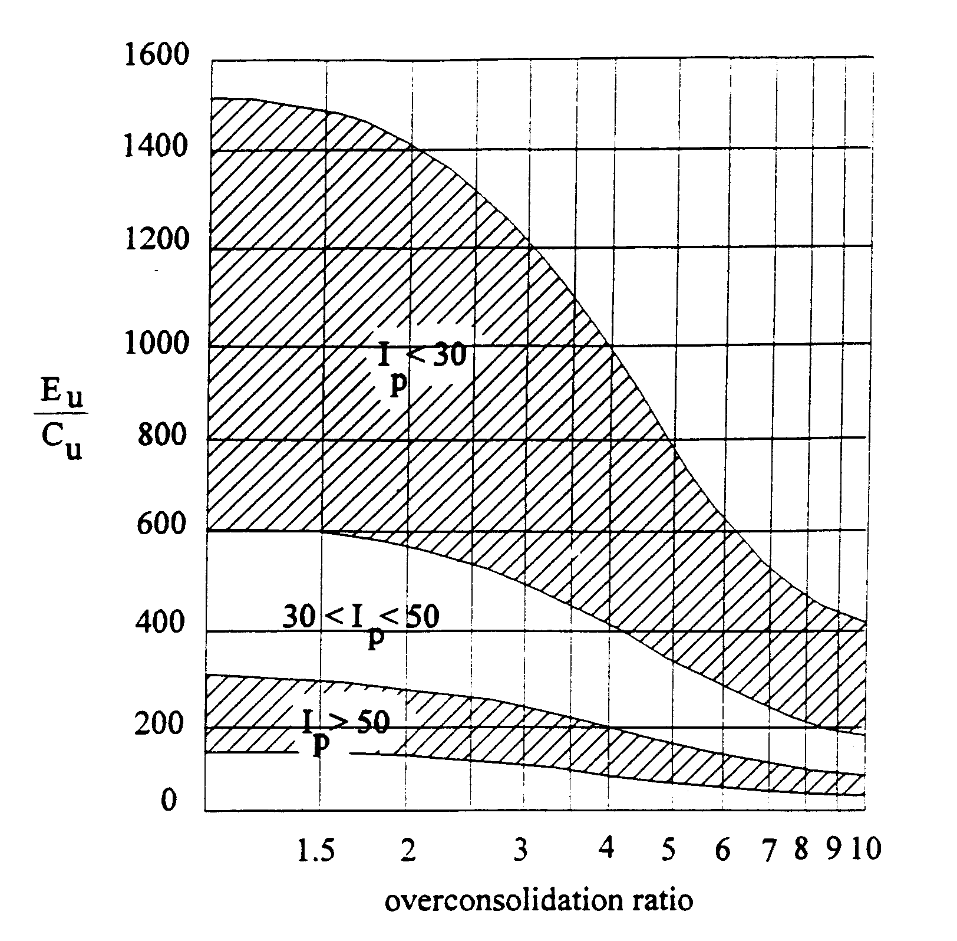

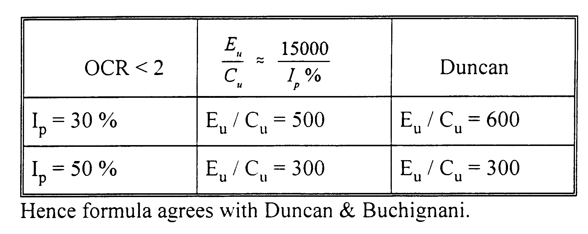
Summary on Stiffness Parameters: Clay
Undrained Conditions

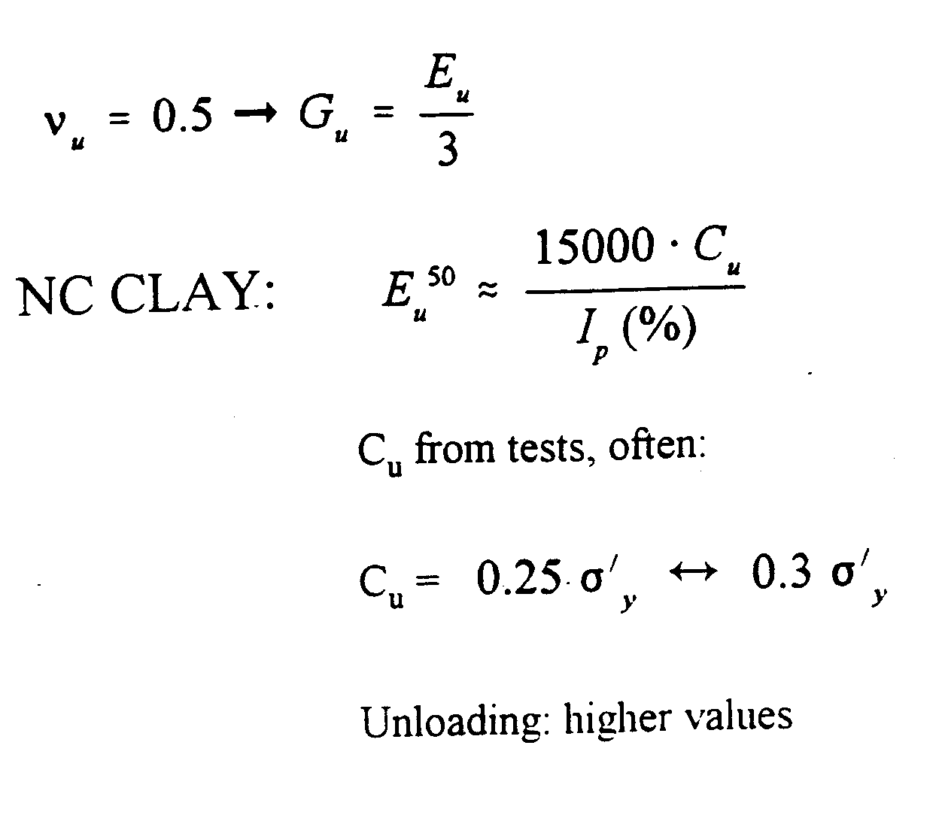

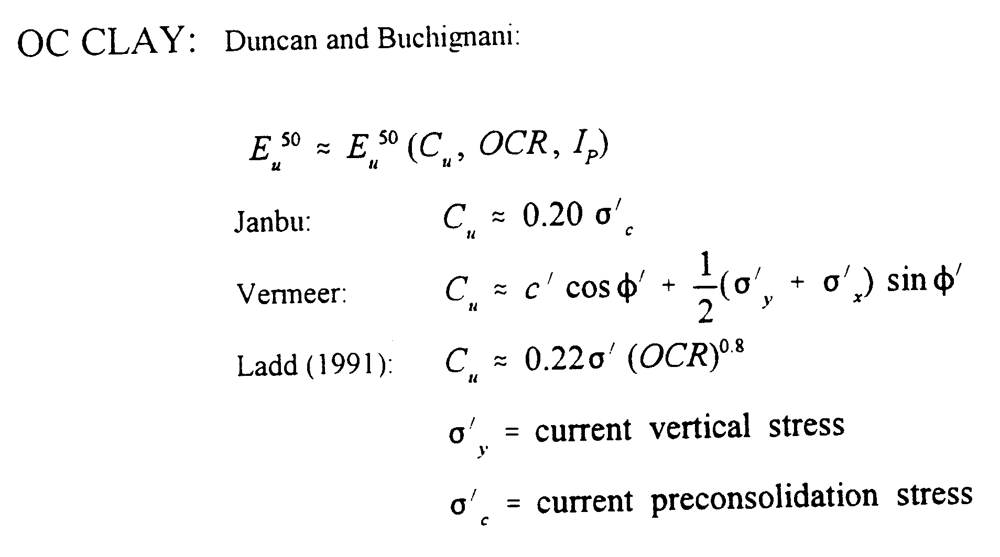
Do not use empirical relationships only. Get good quality experimental data from lab tests, cone penetration tests and vane tests
Drained Behavior for Clays

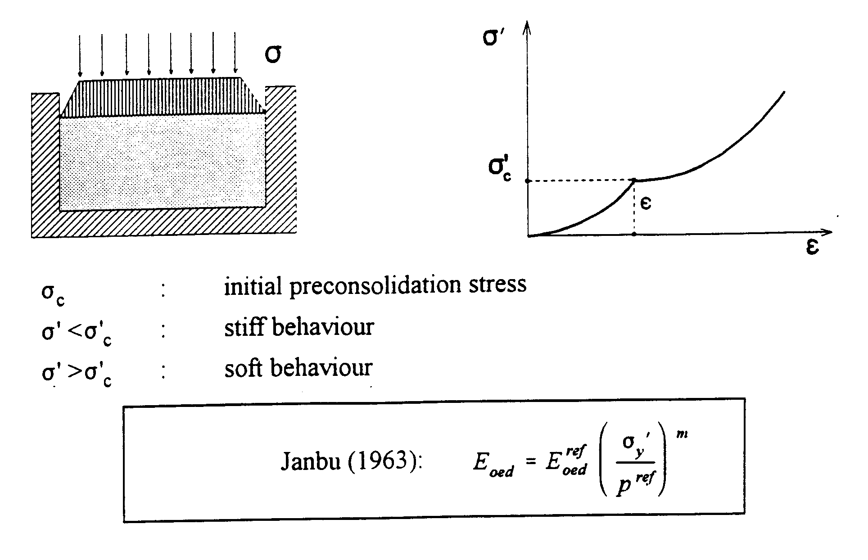

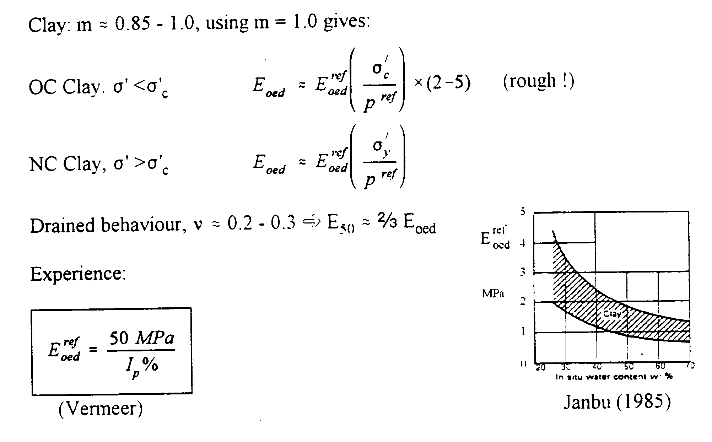
Summary on Stiffness Parameters: Clay
Drained Conditions

For loading:
For unloading
NC Clay: | Soft:
 | Dense:
 | Soft:
 | Dense:
OC Clay: (large variations, be careful)
 | Soft: | $$\frac{E_{\text{oed}}}{p^{\text{ref}}}=\text{10}\frac{σ_{c}^{'}}{p^{\text{ref}}}×(2↔5)$$
 | Dense: | $$\frac{E_{\text{oed}}}{p^{\text{ref}}}=\text{30}\frac{σ_{c}^{'}}{p^{\text{ref}}}×(2↔5)$$
 | Soft:
 | Dense:

Relationships Between Elastic Constants

