Non-Linear Hyperbolic Model & Parameter Selection

(Introduction to the Hardening Soil Model)

(following initial development by
Tom Schanz at Bauhaus-Universität Weimar, Germany)

Computational Geotechnics

Contents

Introduction
Stiffness Modulus
Triaxial Data
Plasticity
HS-Cap-Model
Simulation of Oedometer and Triaxial Tests on Loose and Dense Sands
Summary

Introduction

Hardening Soils
Most soils behave in a nonlinear behavior soon after application of shear stress. Elastic-plastic hardening is a common technique, also used in PLAXIS.

Usage of the Soft Soil model with creep
Creep is usually of greater significance in soft soils.

Hyperbolic stress-strain law for triaxial response curves

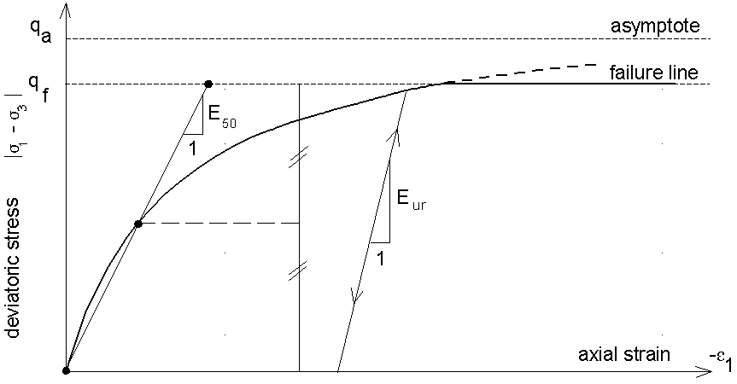
Fig. 1: Hyperbolic stress strain response curve of Hardening Soil model

(standard PLAXIS setting Version 7)
Stiffness Modulus

Elastic unloading and reloading (Ohde, 1939)

We use the two elastic parameters ν_{ur} and E_{ur}:

Initial (primary) loading

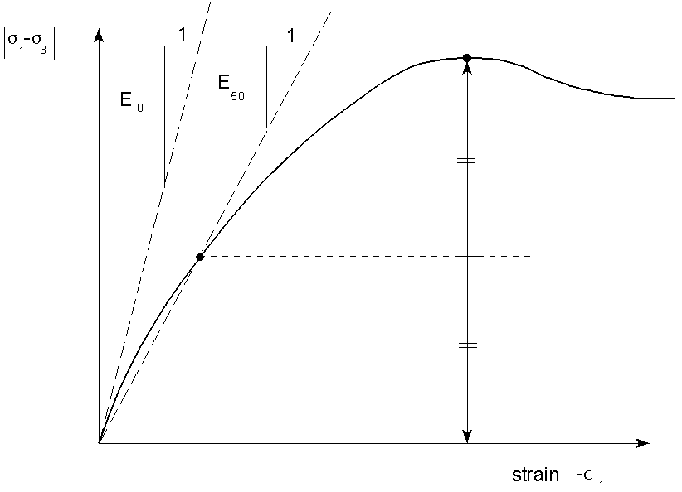
Fig. 2: Definition of E₅₀ in a standard drained triaxial experiment
Stiffness Modulus

Oedometer tests
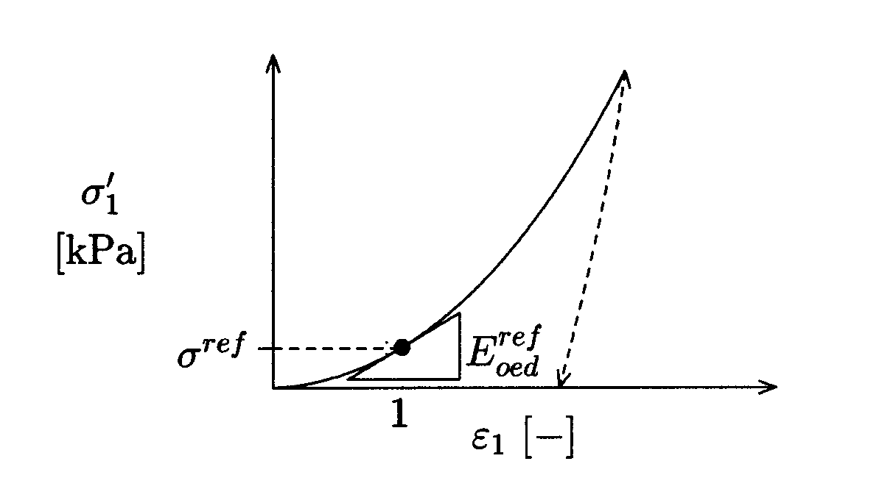
Fig. 3: Definition of the normalized oedometric stiffness

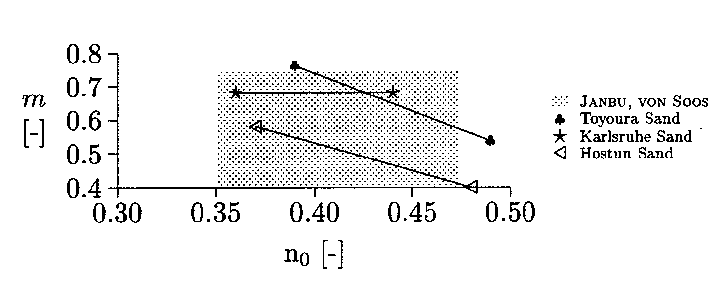
Fig. 4: Values for m from oedometer test versus initial porosity n₀

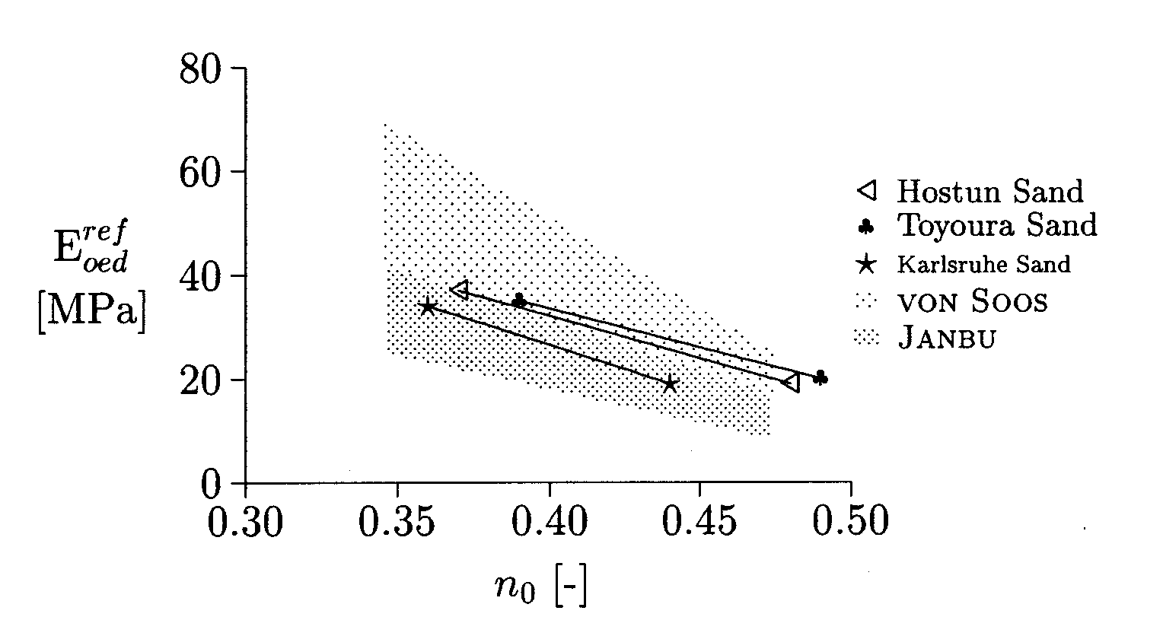
Fig. 5: Normalized oedometer modulus versus initial porosity n₀
Stiffness Modulus

Triaxial tests

Fig. 6: Normalized oedometric stiffness for various soil classes (von Soos, 1991)
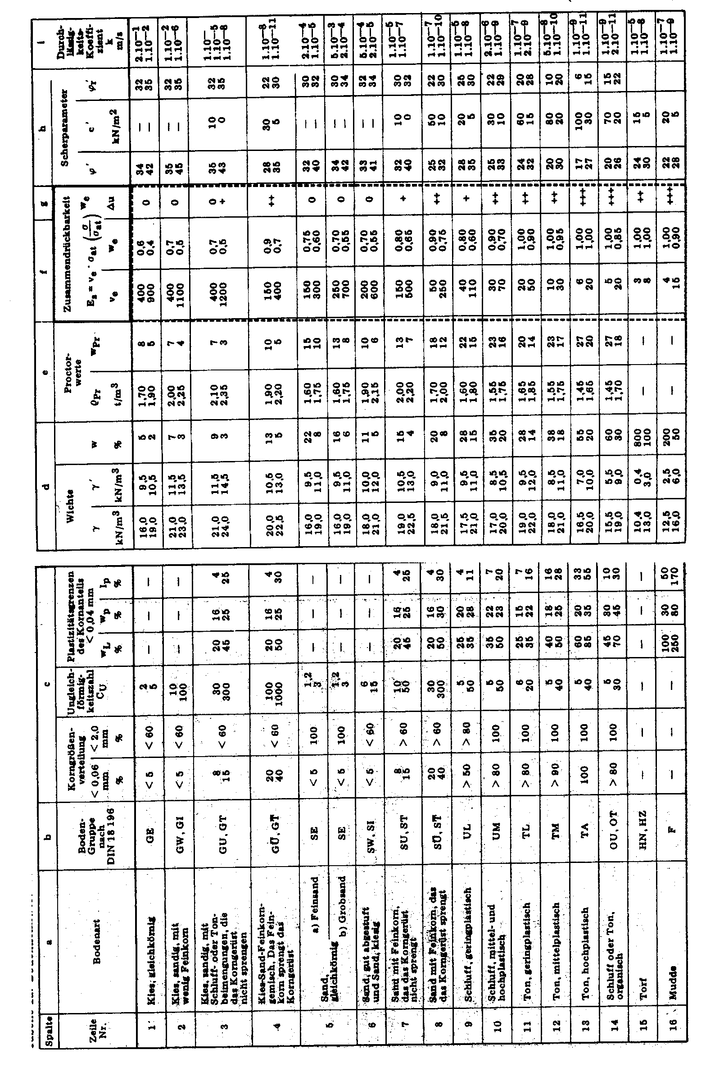
Stiffness Modulus

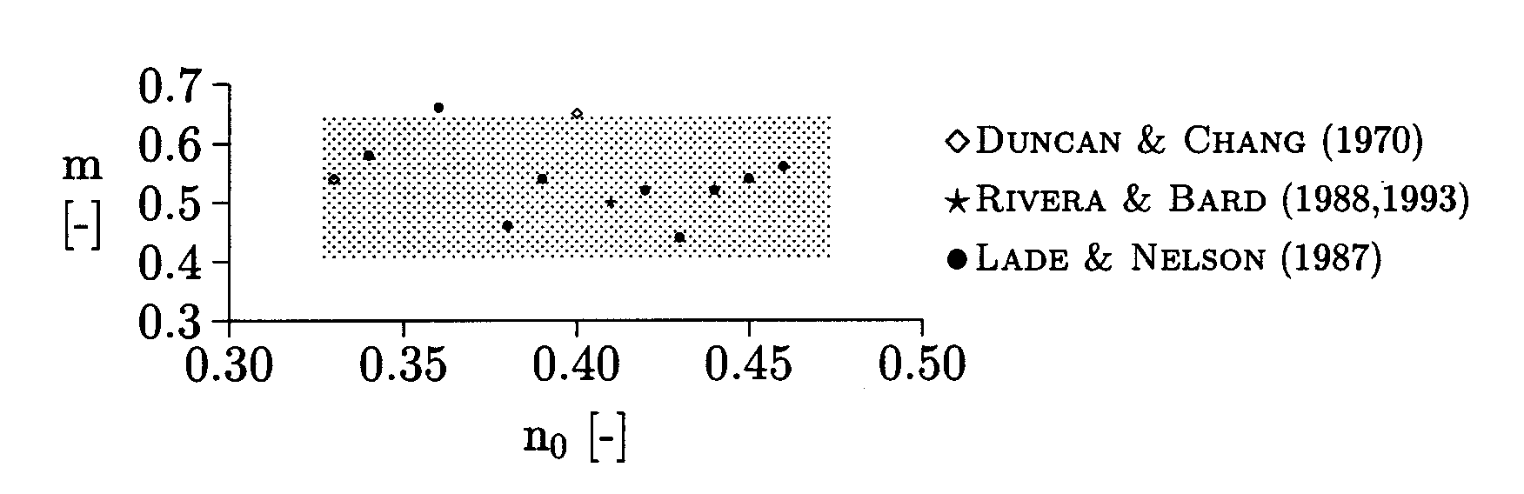
Fig. 7: Values for m obtained from triaxial test versus initial porosity n₀

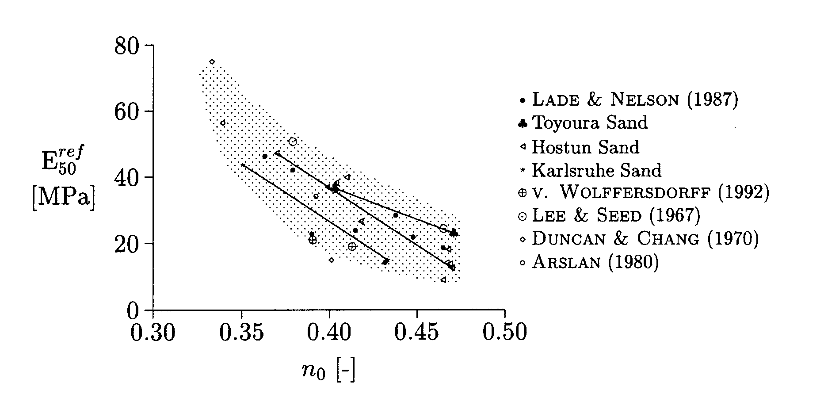
Fig. 8: Normalized triaxial modulus versus initial porosity n₀
Stiffness Modulus

Summary of data for sand: Vermeer & Schanz (1997)

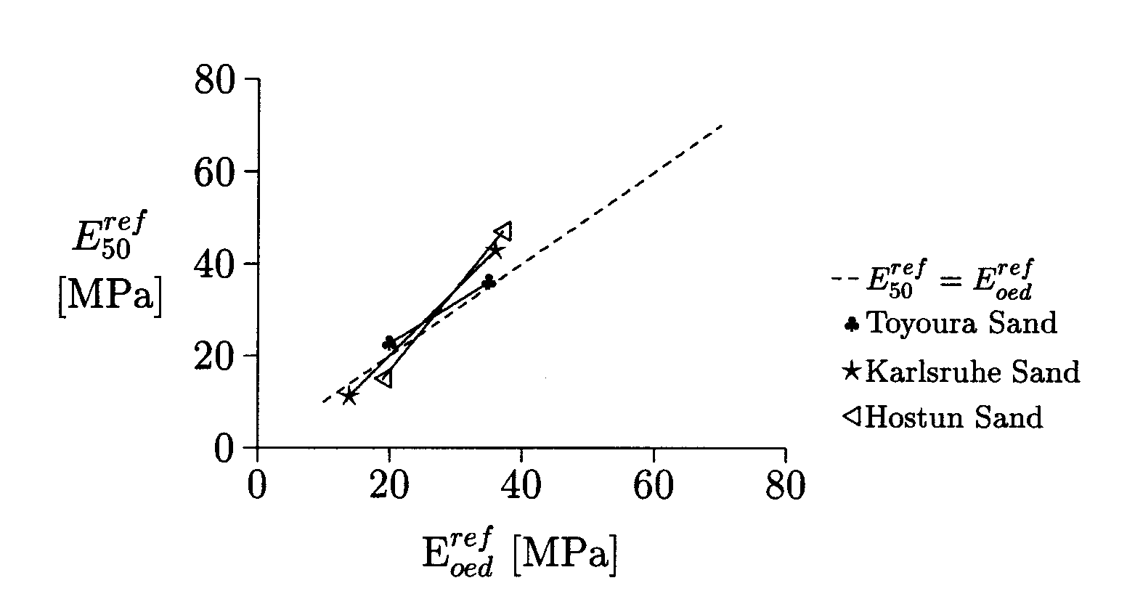
Fig. 9: Comparison of normalized stiffness moduli from oedometer and triaxial tests

Engineering practice: mostly data on E_{oed}

Test data:

(standard setting PLAXIS version 7)

Triaxial Data on γ^{p} ≈ 2ε₁^{p}

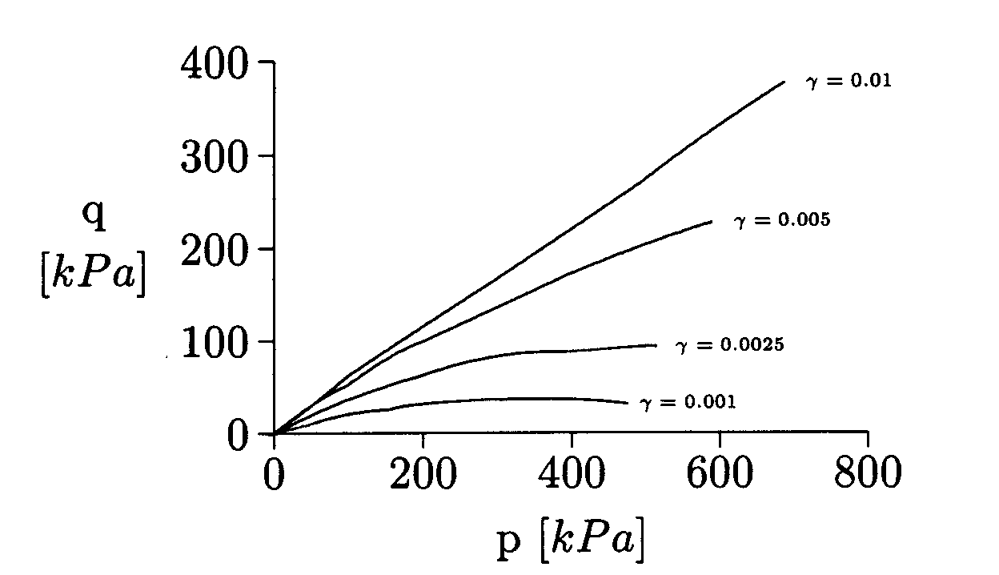
Fig. 10: Equi-g lines (Tatsuoka, 1972) for dense Toyoura Sand

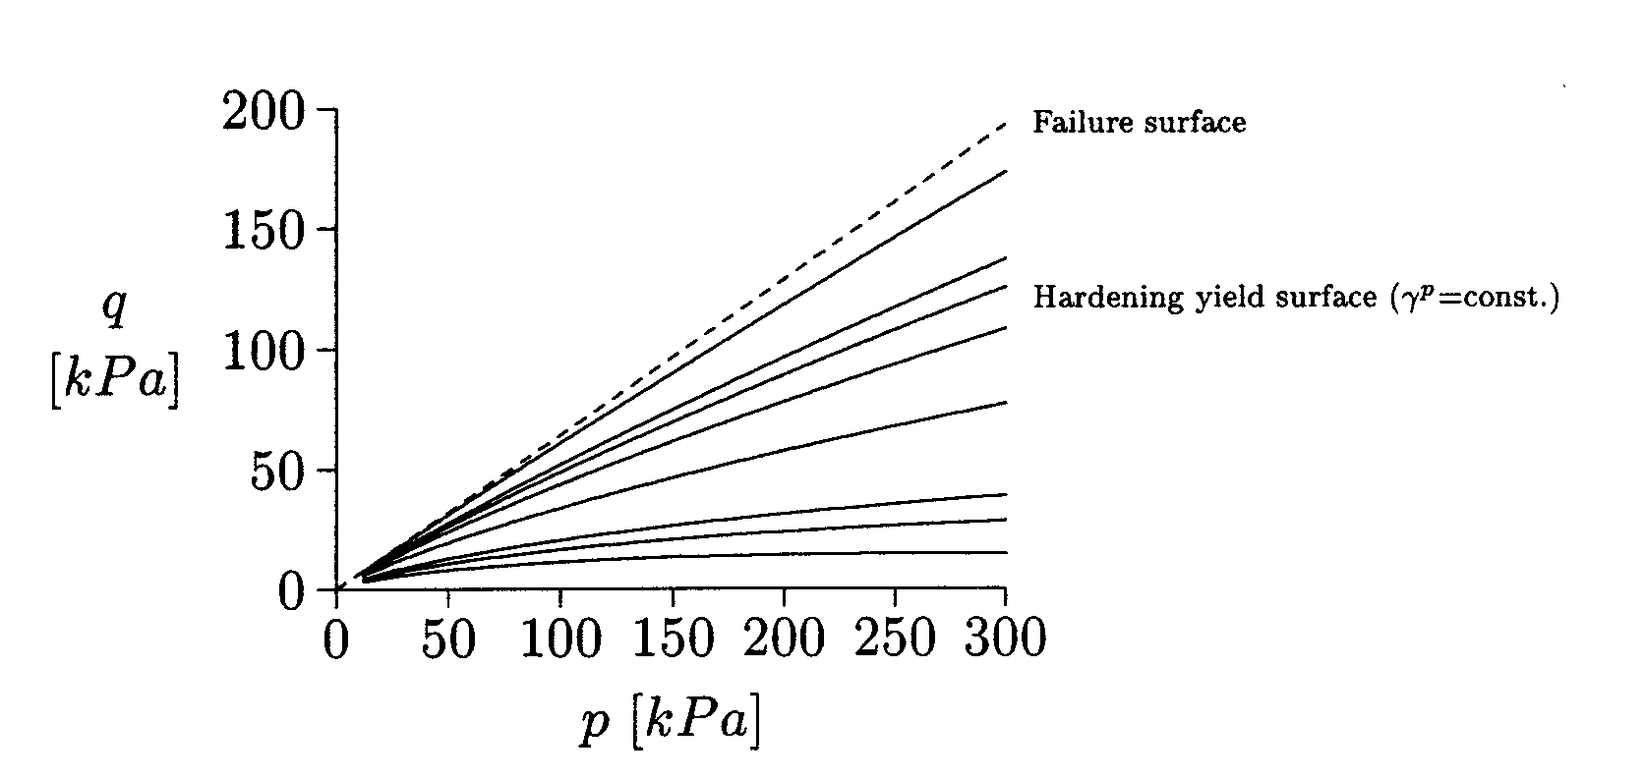
Fig. 11: Yield and failure surfaces for the Hardening Soil model
Plasticity

Yield and hardening functions

3D extension

In order to extent the model to general 3D states in terms of stress, we use a modified expression for in terms of and the mobilized angle of internal friction

with

where

Plasticity

Plastic potential and flow rule

with
where

Flow rule

with

Table 1: Primary soil parameters and standard PLAXIS settings
C [kPa] | ϕ’ [o] | ψ [o] | E50 [Mpa]
0 | 30-40 | 0-10 | 40
Eur = 3 E50 | Vur = 0.2 | Rf = 0.9 | m = 0.5 | Pref = 100 kPa
Plasticity

Hardening soil response in drained triaxial experiments

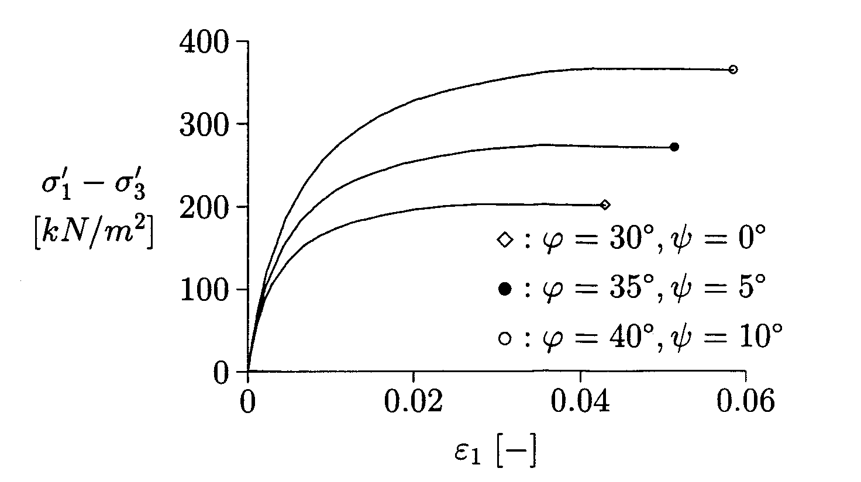
Fig. 12: Results of drained triaxial loading: stress-strain relations (s3 = 100 kPa)

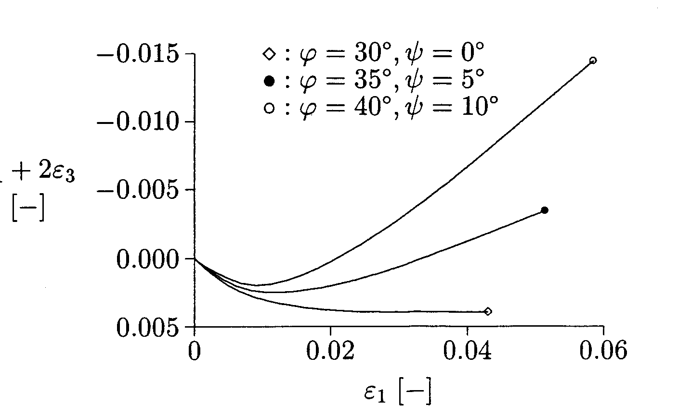
Fig. 13: Results of drained triaxial loading: axial-volumetric strain relations (s3 = 100 kPa)
Plasticity

Undrained hardening soil analysis

Method A: switch to drained
Input:

Method B: switch to undrained
Input:

Interesting in case you have data on C_{u} and not no C’ and φ’
Assume and use graph by Duncan & Buchignani (1976) to estimate E_{u}
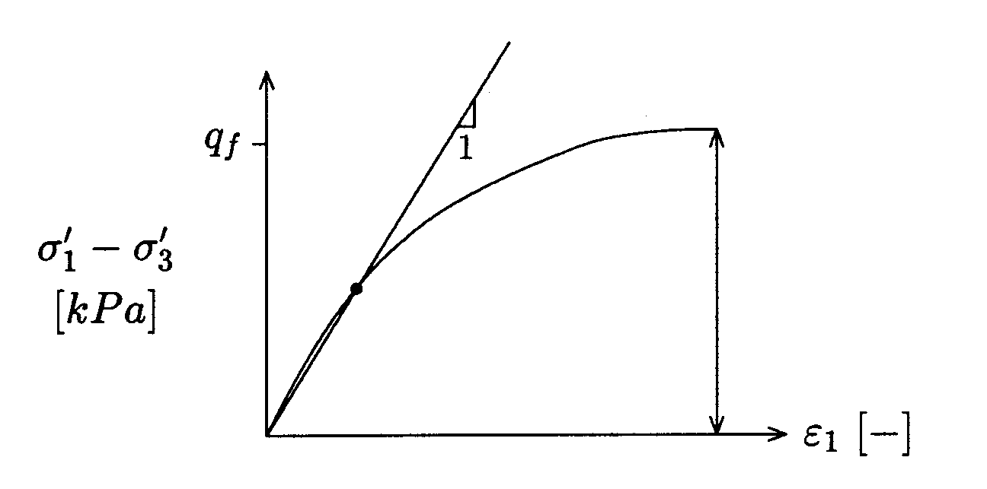
2c_{u}
E_{u} ≈ 1.4 E₅₀
Fig. 14: Undrained Hardening Soil analysis
Plasticity

Hardening soil response in undrained triaxial tests

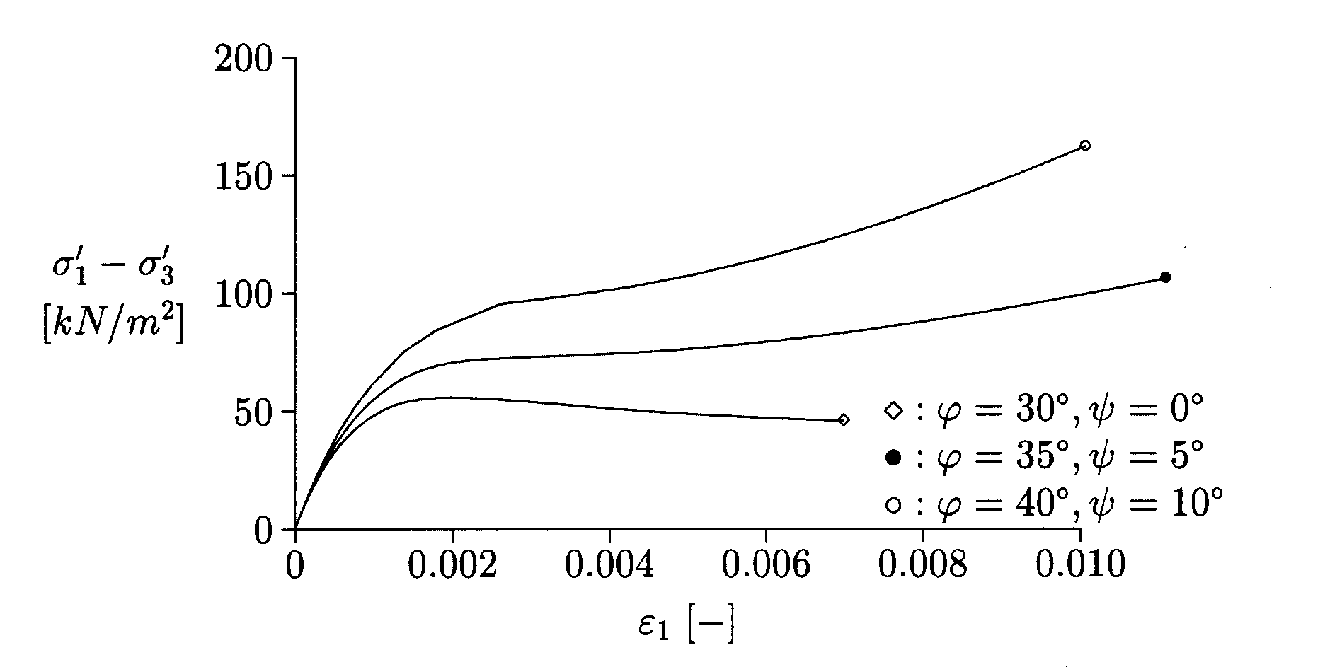
Fig. 15: Results of undrained triaxial loading: stress-strain relations (s3 = 100 kPa)

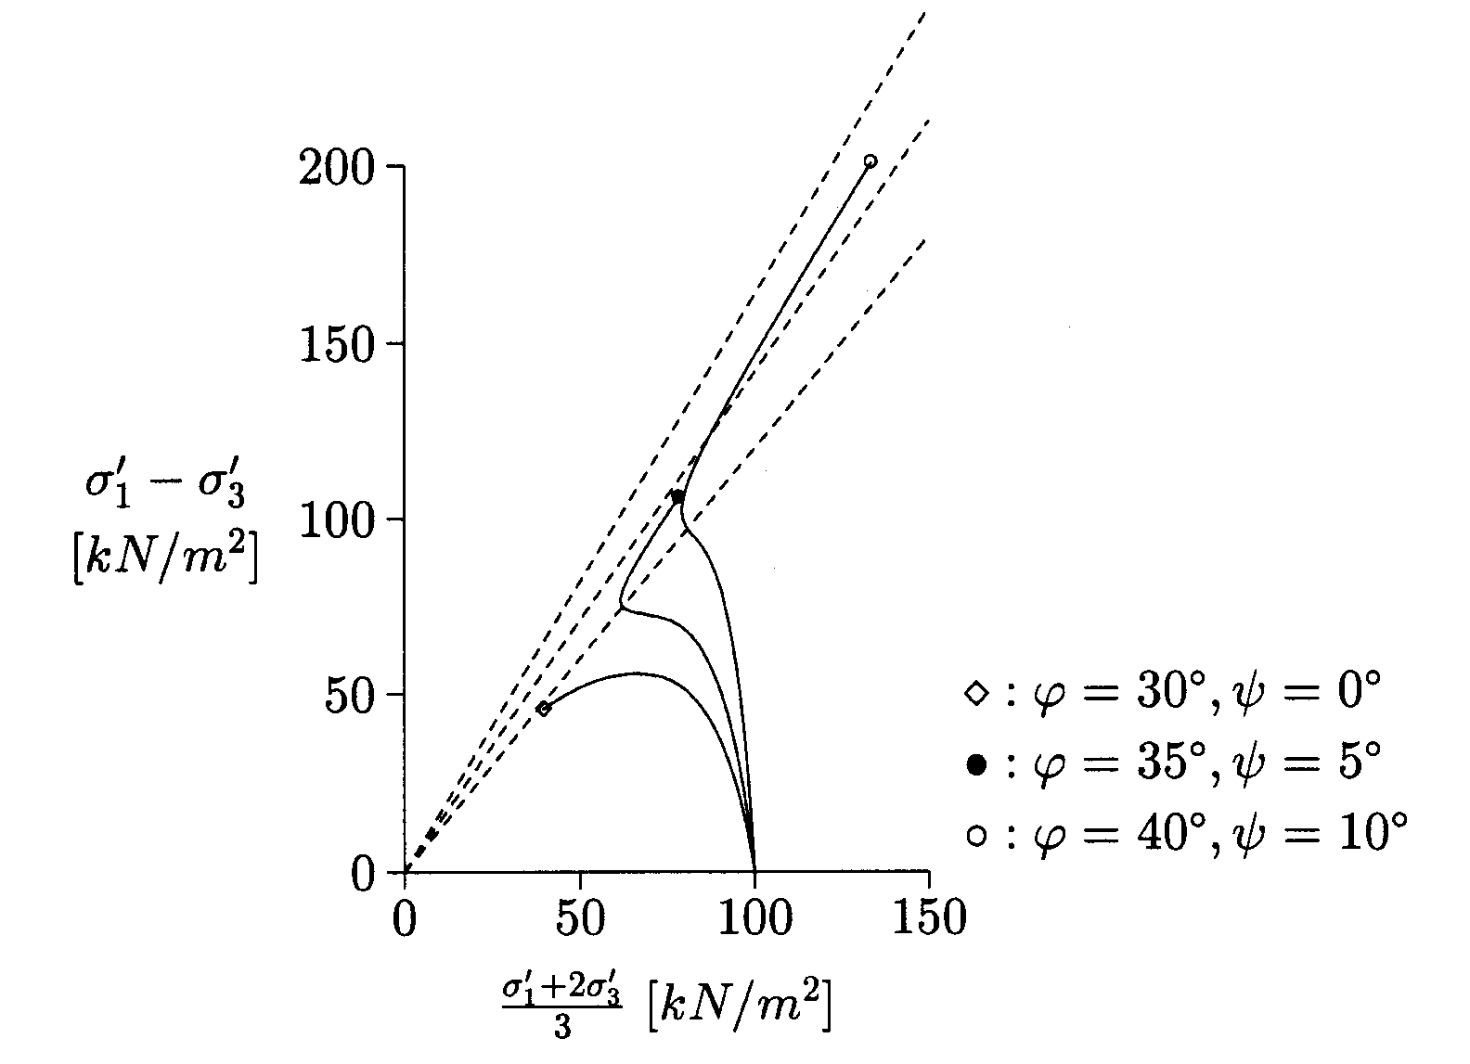
Fig. 16: Results of undrained triaxial loading: p-q diagram (s3 = 100 kPa)
HS-Cap-Model

Cap yield surface

Flow rule
(Associated flow)

Hardening law

For isotropic compression we assume

With

For isotropic compression we have q = 0 and it follows from

For the determination of, we use another consistency condition:
HS-Cap-Model

Additional parameters
The extra input parameters are and

The two auxiliary material parameter M and Kc/Ks are determined iteratively from the simulation of an oedometer test. There are no direct input parameters. The user should not be too concerned about these parameters.

Graphical presentation of HS-Cap-Model

I: | Purely elastic response
II: | Purely frictional hardening with f
III: | Material failure according to Mohr-Coulomb
IV: | Mohr-Coulomb and cap fc
V: | Combined frictional hardening f and cap fc
VI: | Purely cap hardening with fc
VII: | Isotropic compression

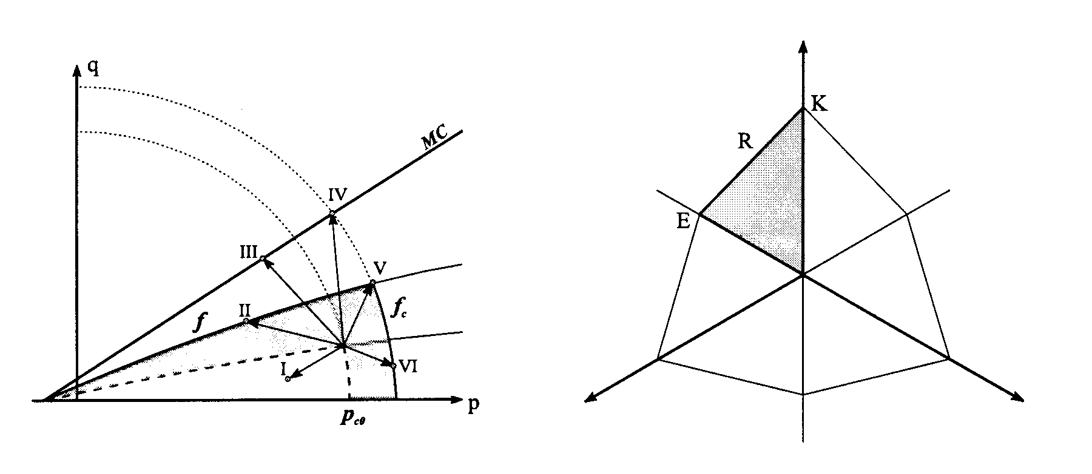
1
2
3
Fig. 17: Yield surfaces of the extended HS model in p-q-space (left) and in the deviatoric plane (right)
HS-Cap-Model

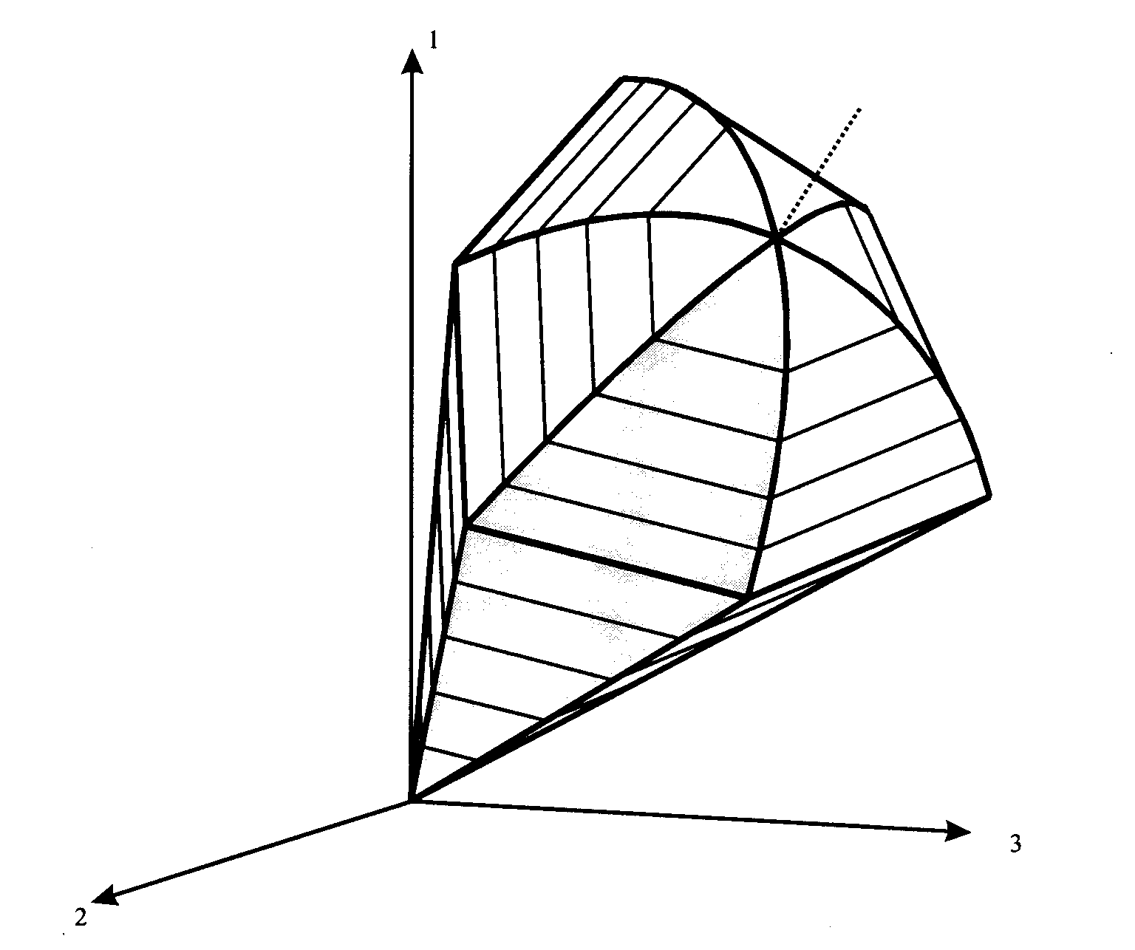
σ₁ = σ₂ = σ₃

Fig. 18: Yield surfaces of the extended HS model in principal stress space

Simulation of Oedometer and Triaxial Tests on Loose and Dense Sands

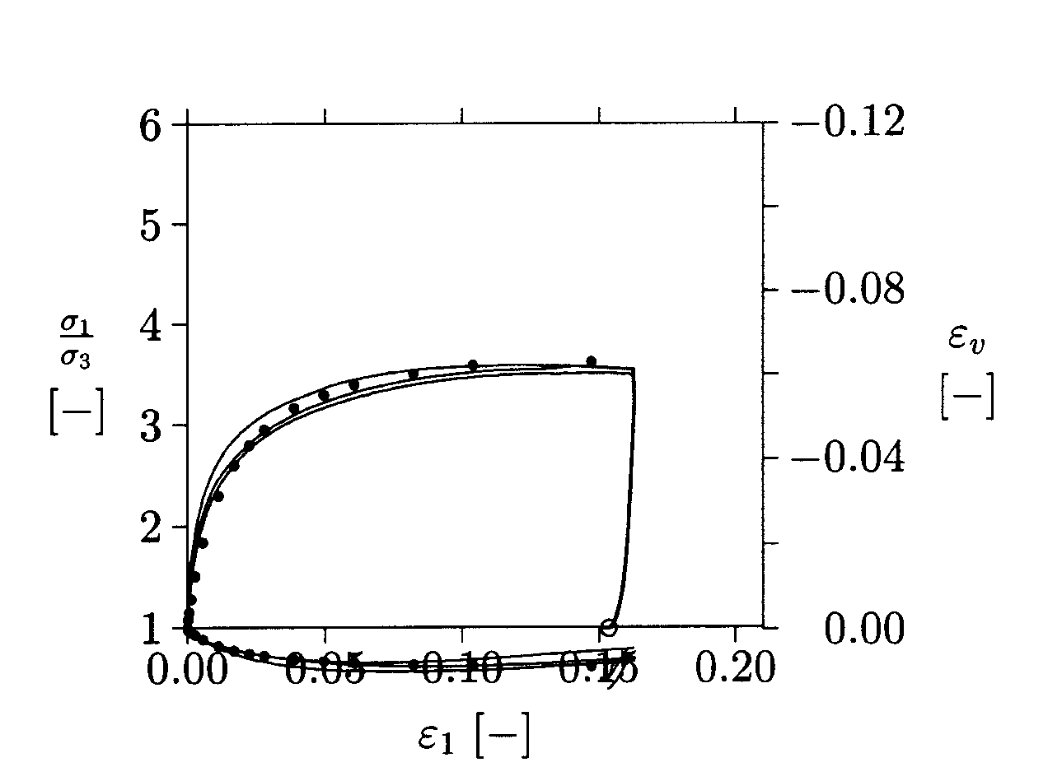
Fig. 19: Comparison of calculated (•) and measured triaxial tests on loose Hostun Sand

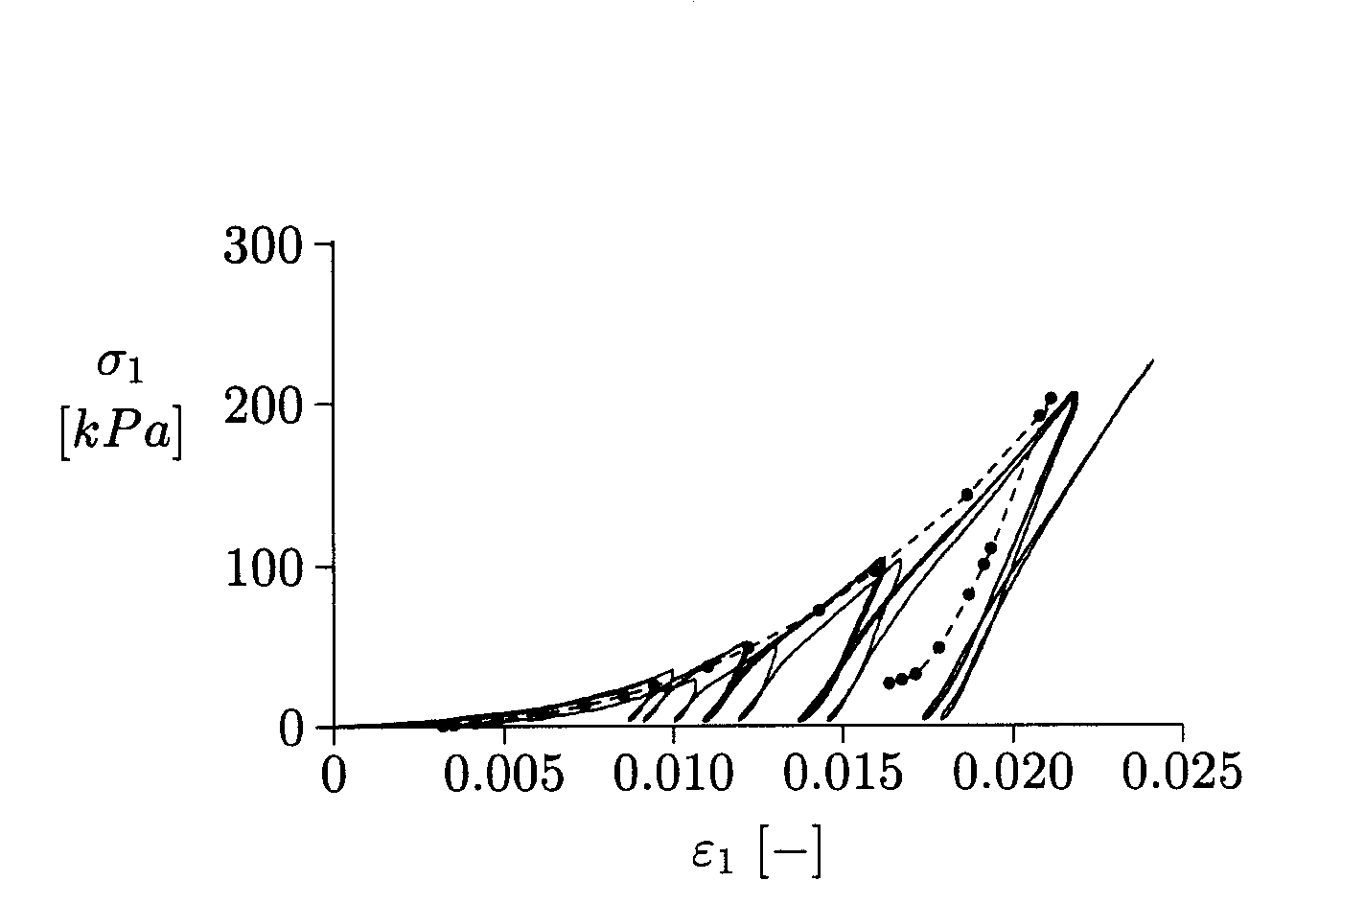
Fig. 20: Comparison of calculated (•) and measured oedometer tests on loose Hostun Sand
Simulation of Oedometer and Triaxial Tests on Loose and Dense Sands

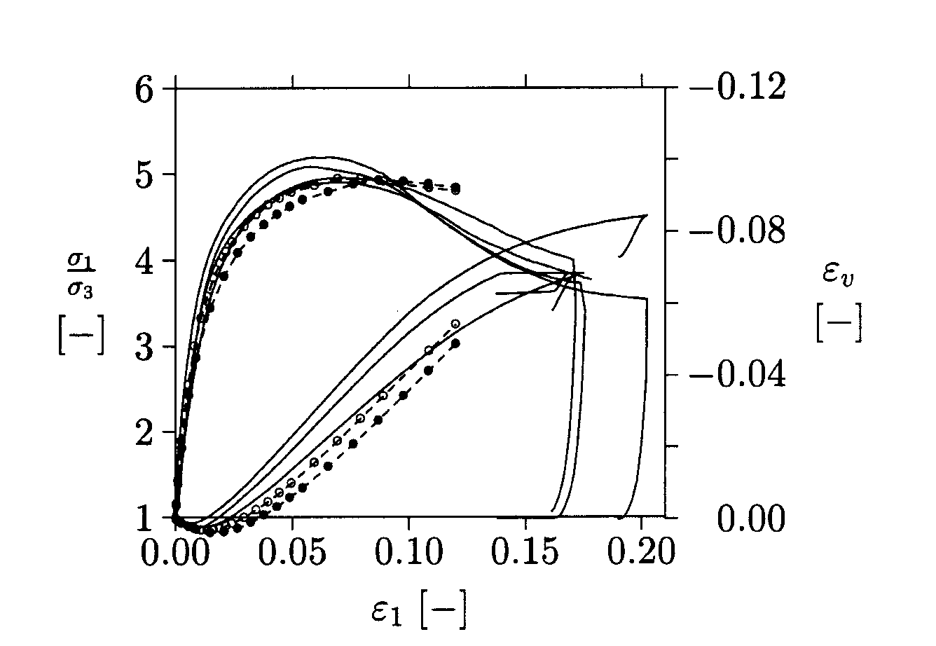
Fig. 21: Comparison of calculated (•) and measured triaxial tests on dense Hostun Sand

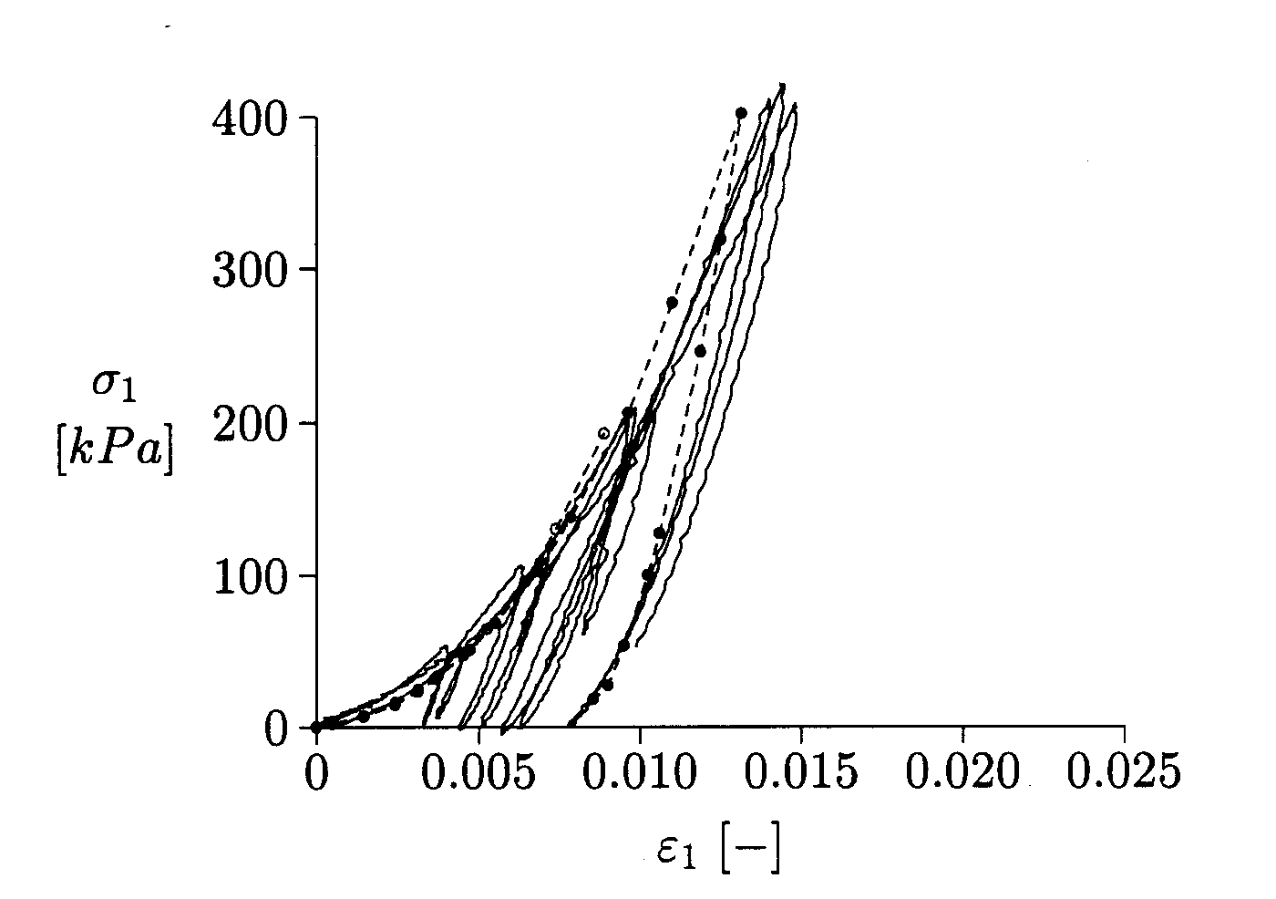
Fig. 22: Comparison of calculated (•) and measured oedometer tests on dense Hostun Sand

Summary

Main characteristics
Pressure dependent stiffness
Isotropic shear hardening
Ultimate Mohr-Coulomb failure condition
Non-associated plastic flow
Additional cap hardening

HS-model versus MC-model

As in Mohr-Coulomb model
Normalized primary loading stiffness
Unloading / reloading Poisson’s ratio
Normalized unloading / reloading stiffness
Power in stiffness laws
Failure ratio

Exercise 1: Calibration of the HS-Cap-Model for Loose and Dense Sand

Oedometer and triaxial shear experimental data for both loose and dense sands are given in Figs. 23 – 26.

Table 2: Parameters for loose and dense sand
 | v_{ur} | m | ϕ | ψ
loose | 0.25 | 0.65 | 34º | 0º | 1.0 | 3.0 | 16
dense | 0.25 | 0.65 | 41º | 14º | 0.9 | 3.0 | 35 MPa

Proceed according to the following steps:

Use Ko = 1 – sinφ and E_{oed}/E₅₀ according to Table 2 in the advanced material parameter input in PLAXIS.

For both simulations use an axis-symmetric mesh (1x 1 [m]) with a coarse element density. Change loading and boundary conditions according to the test conditions.

Simulation of oedmoter tests with unloading for unloading for maximum axial stress.
Loose sand:
Dense sand:

If necessary improve given material parameters to obtain a more realistic response.

Check triaxial tests with the parameters obtained from the oedometer simulation.
Exercise 1: Calibration of the HS-Cap-Model for Loose and Dense Sand

Results for loose sand

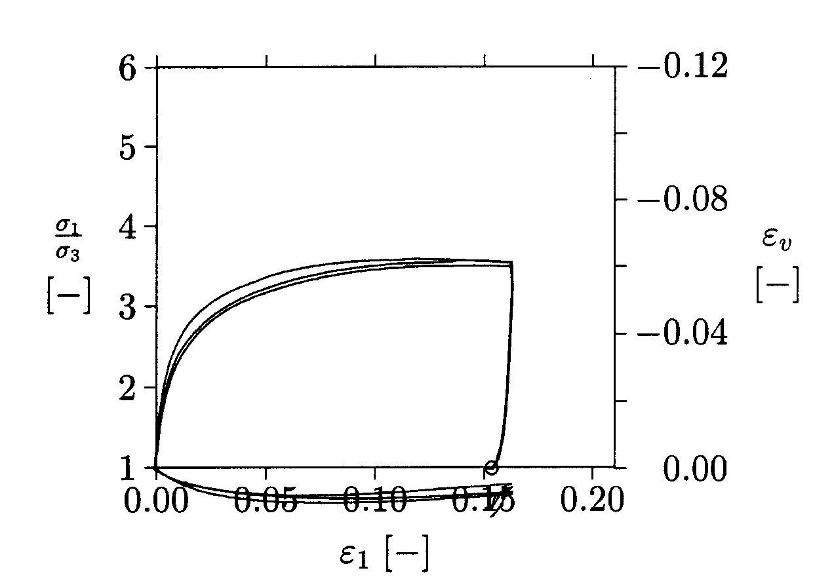
Fig. 23: Triaxial tests on loose Hostun Sand

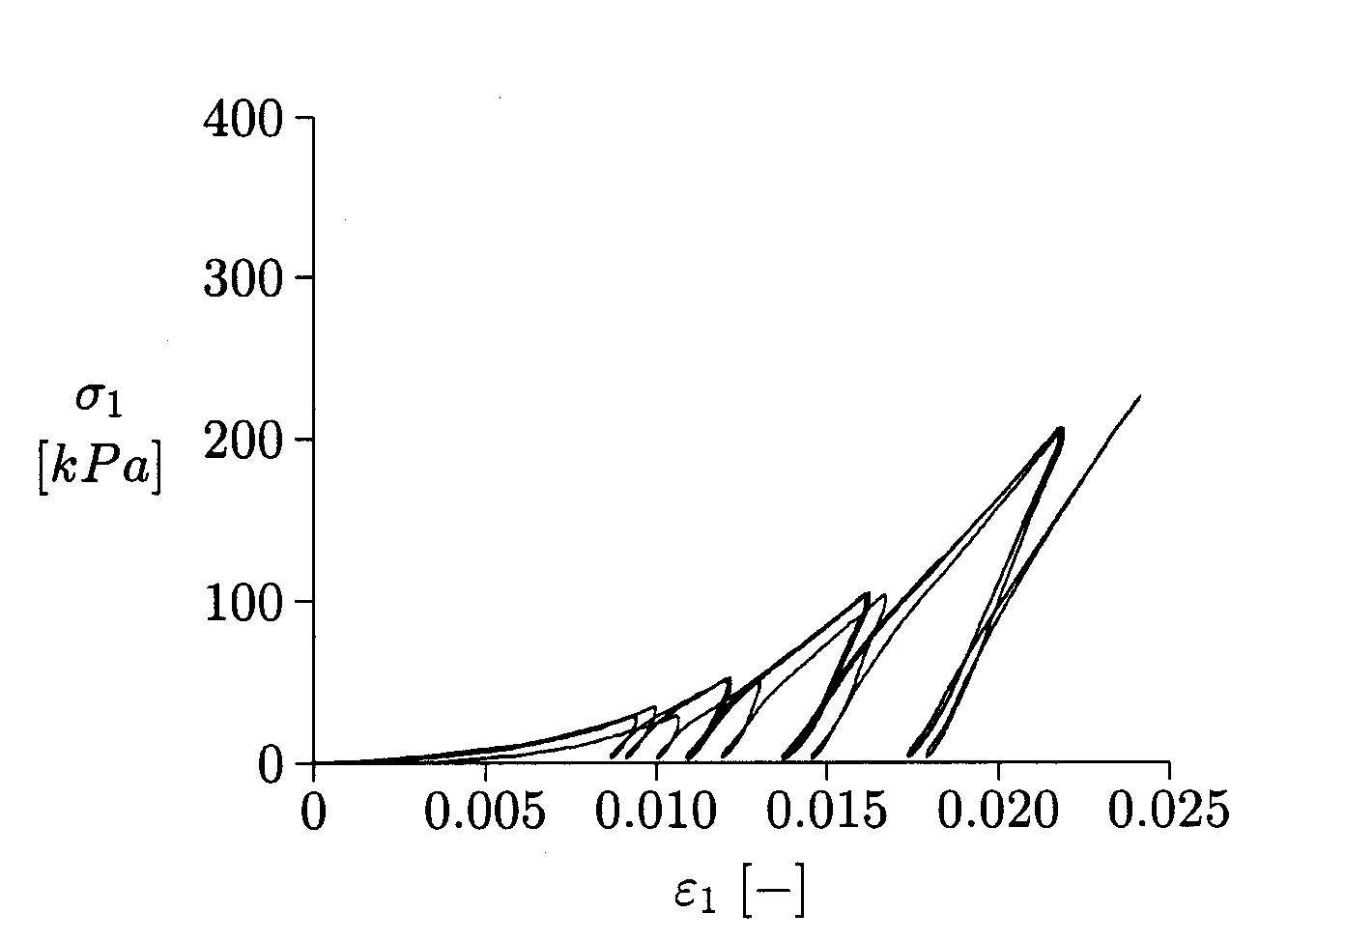
Fig. 24: Oedometer tests on loose Hostun Sand
Exercise 1: Calibration of the HS-Cap-Model for Loose and Dense Sand

Results for dense sand

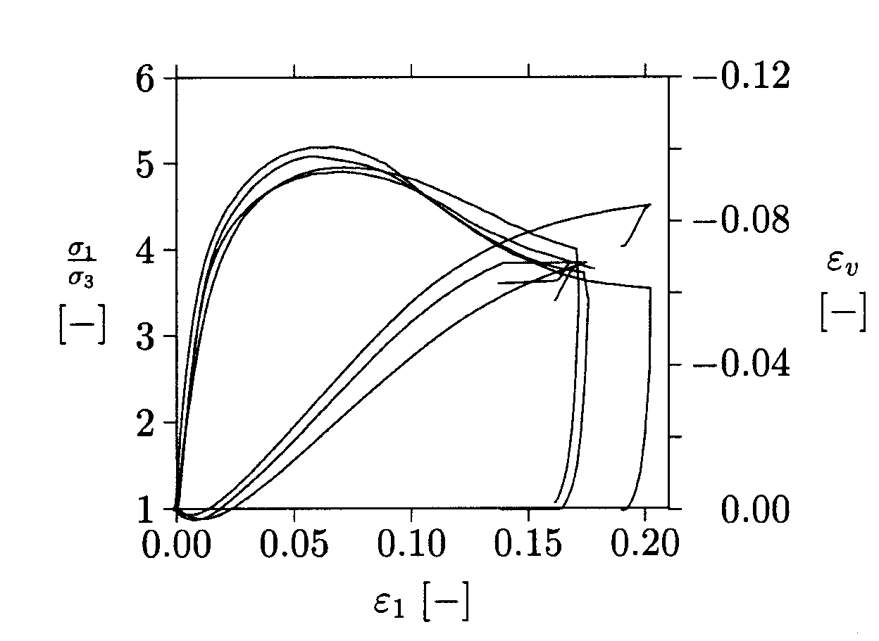
Fig. 25: Triaxial tests on dense Hostun Sand

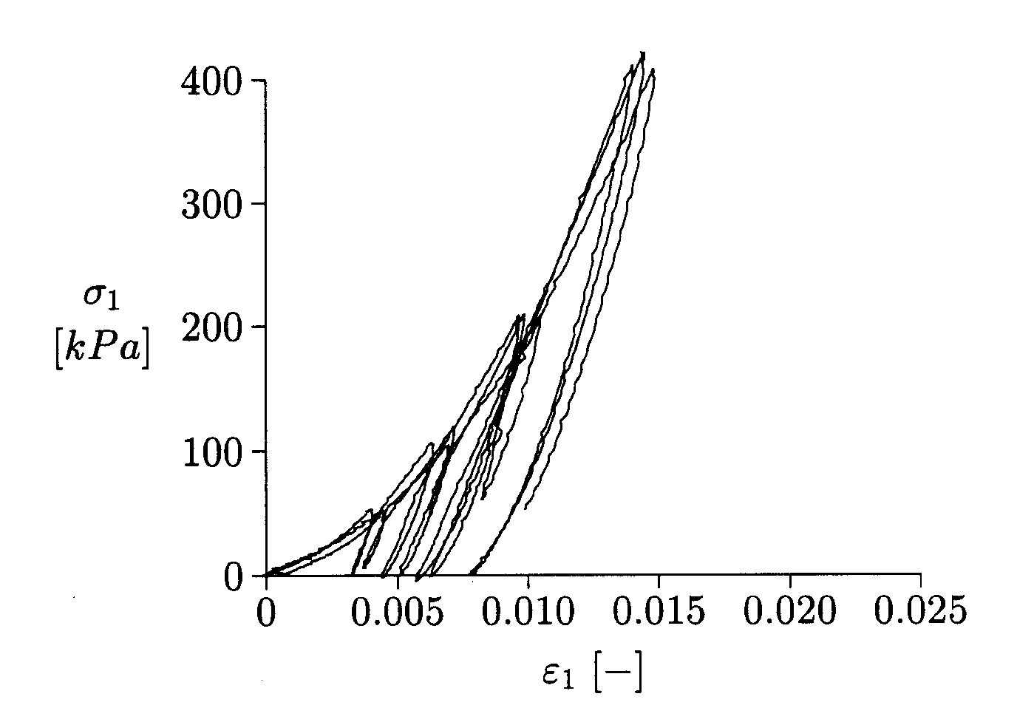
Fig. 26: Oedometer tests on dense Hostun Sand

