Mohr-Coulomb Model

Computational Geotechnics
Contents

Idealized and Real Stress-Strain Behavior of Soils
Basic Concepts of Mohr-Coulomb Model
Mohr-Coulomb Model Modeling
Friction Angle
Influence of Intermediate Principal Stress on Friction Angle
Drained Simple Shear Test
How to Understand ψ
Drained Triaxial Test
Reference
Appendix A
Appendix B
Idealized and Real Stress-Strain Behavior of Soils

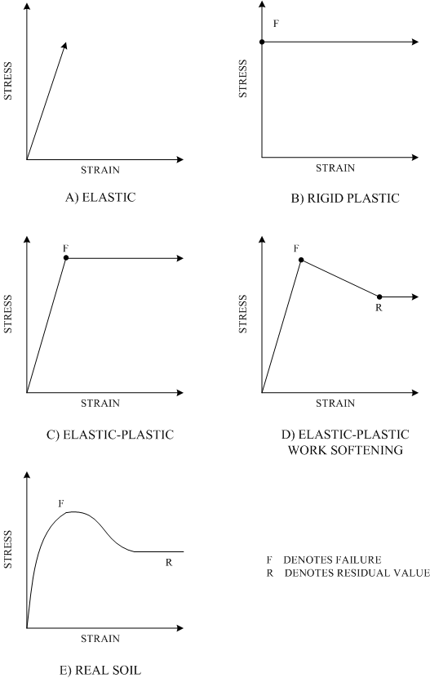
Basic Concepts of Mohr-Coulomb Model

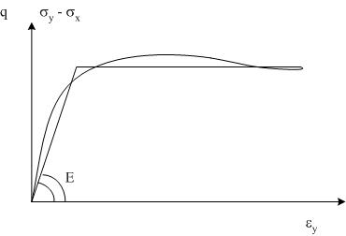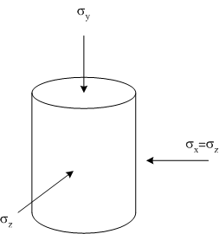

Bilinear approximation of triaxial test

Basic law: |  | i = x, y, etc.
 | reversible elastic strain
 | irreversible plastic strain

for f < 0
f = yield function
Mohr-Coulomb Soil Modeling

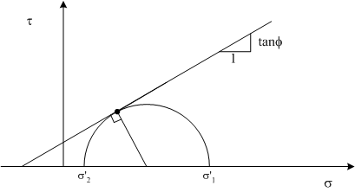

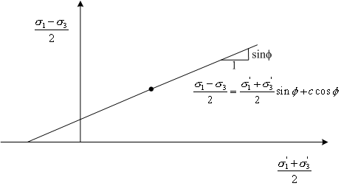
Mohr-Coulomb Soil Modeling

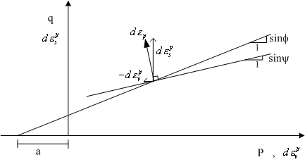

Flow rule for plastic strains:
This means: |  |  | , , etc.
 | a multiplier that determines the magnitude of plastic strains
 |  | determines the direction of plastic strains

Classical associated plasticity: g = f
General non-associated plasticity: g ≠ f
M-C model: f ≡ r – s sinφ – c cosφ : yield function
g ≡ r – s sinψ – c cosψ : plastic potential function
Mohr-Coulomb Soil Modeling

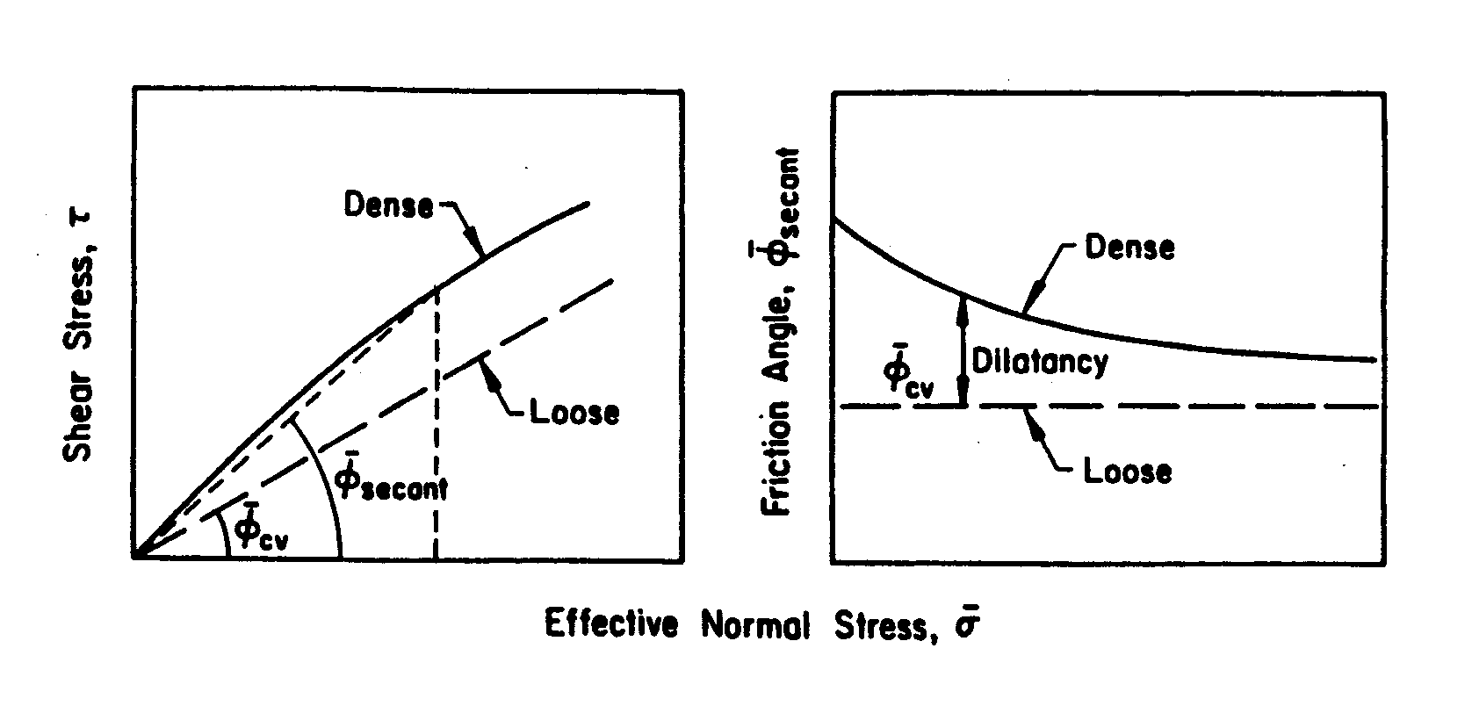
Nonlinear Failure Envelope Representation

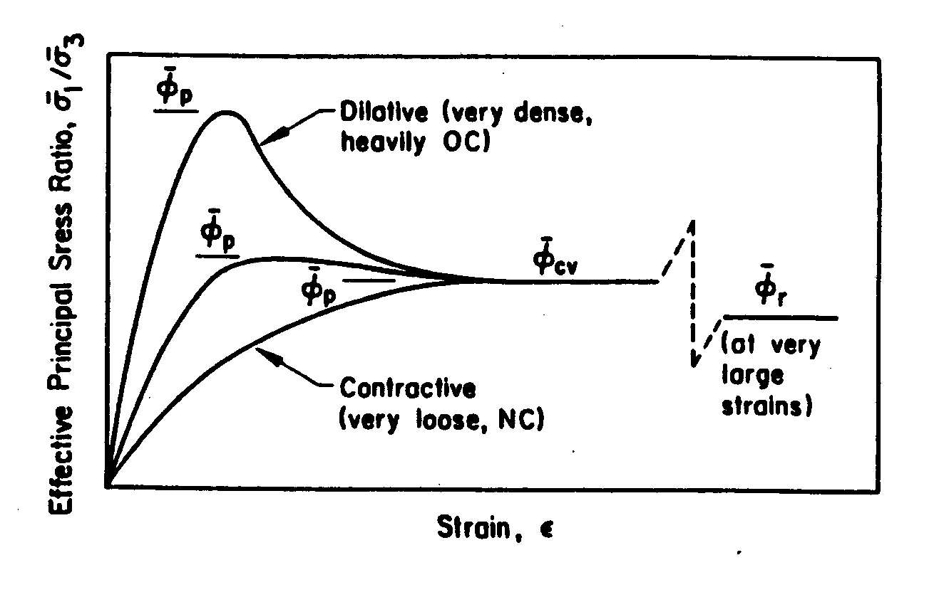
Friction Angle Definitions

(Kulhawy and Mayne, 1990)

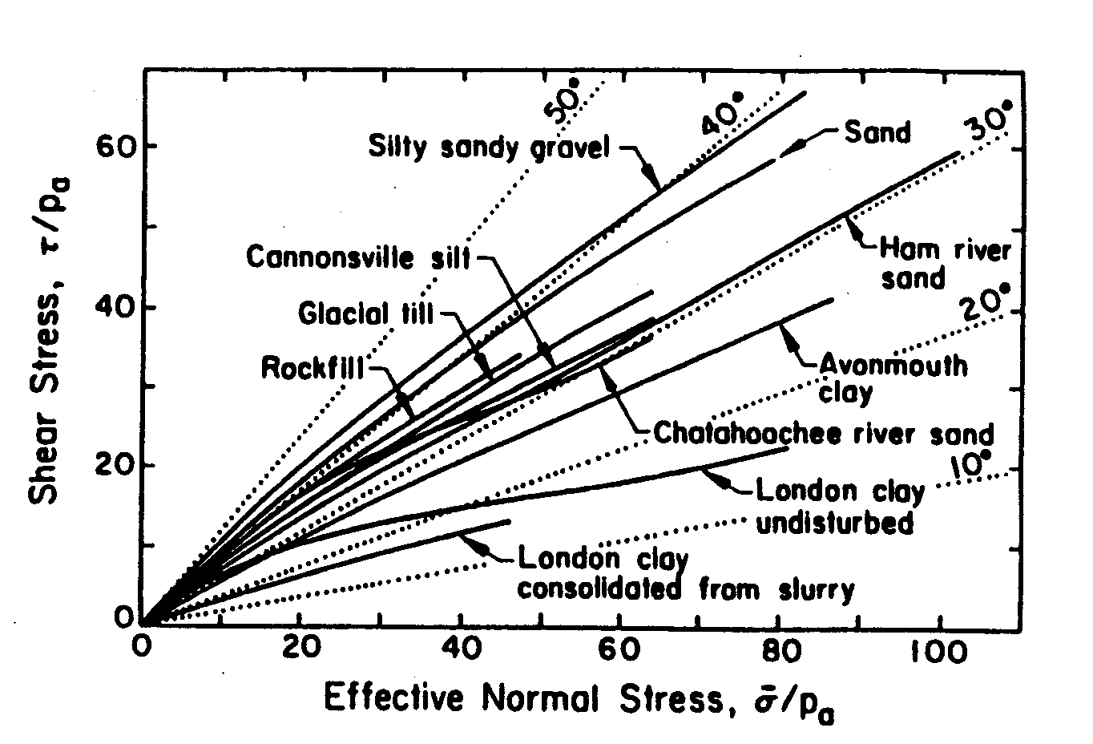
Strength Envelopes for a Range of Soil Types

(Bishop, A.W., 1966)

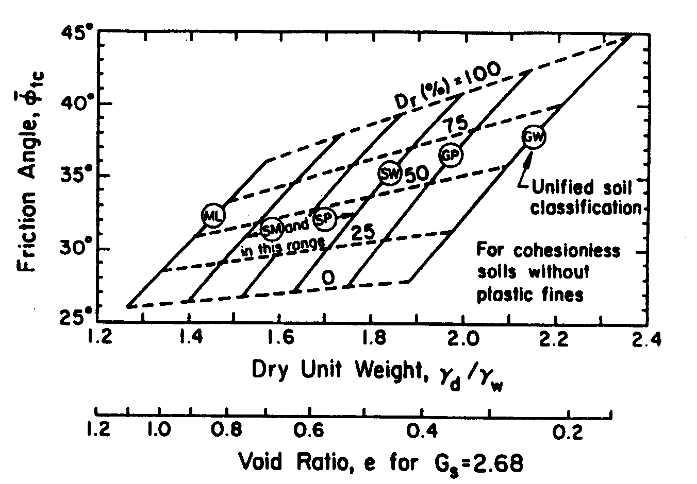
versus Relative Density and Unit Weight

(NAVFAC, “Soil Mechanics Design Manual”, DM-7)
Friction Angle
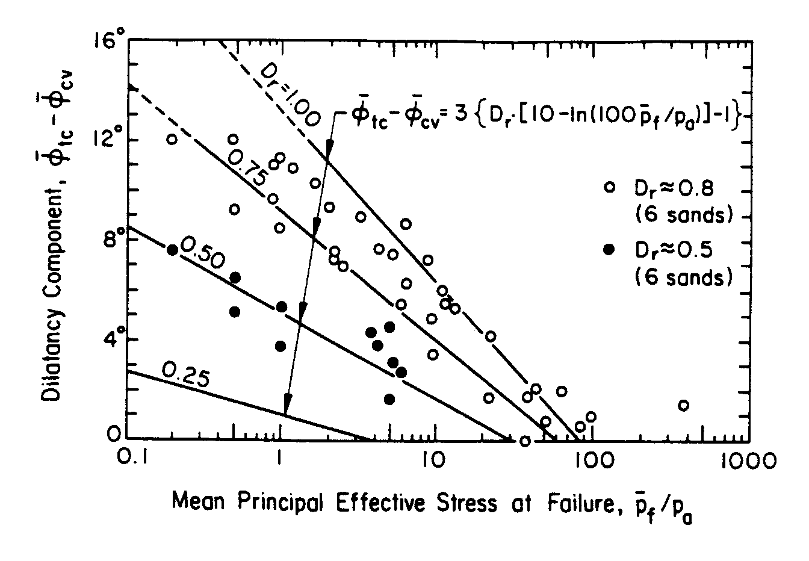
Dilatancy Angle Relationships

(Bolton, M.D., 1986)
in which:

Δφ₁ | = | Correction for particle shape
 |  | Δφ₁ = -6º | For high sphericity and subrounded shape
 |  | Δφ₁ = +2º | For low sphericity and angular shape
Δφ₂ | = | Correction for particle size (effective size, d₁₀)
 |  | Δφ₂ = -11º | For d₁₀ > 2.0 mm (gravel)
 |  | Δφ₂ = -9º | For 2.0 > d₁₀ >0.6 mm (coarse sand)
 |  | Δφ₂ = -4º | For 0.6 > d₁₀ >0.2 mm (medium sand)
 |  | Δφ₂ = 0 | For 0.2 > d₁₀ >0.06 mm (fine sand)
Δφ₃ | = | Correction for graduation (uniformity coefficient, C_{u})
 |  | Δφ₃ = -2º | For C_{u} > 2.0 (well-graded)
 |  | Δφ₃ = -1º | For C_{u} = 2.0 (medium graded)
 |  | Δφ₃ = 0 | For C_{u} < 2.0 (poorly graded)
Δφ₄ | = | Correction for relative density (D_{r})
 |  | Δφ₄ = -1º | For 0 < D_{r} <0.5 (loose)
 |  | Δφ₄ = 0 | For 0.5 < D_{r} < 0.75 (intermediate)
 |  | Δφ₄ = +4º | For 0.75 < D_{r} < 1.00 (dense)
Δφ₅ | = | Correction for type of mineral
 |  | Δφ₅ = 0 | For quartz
 |  | Δφ₅ = +4º | For feldspar, calcite, chlorite
 |  | Δφ₅ = +6º | For muscovite mica
 |  | (Kulhawy and Mayne, 1990)

φ_{cv} for NC Clays vs. PI

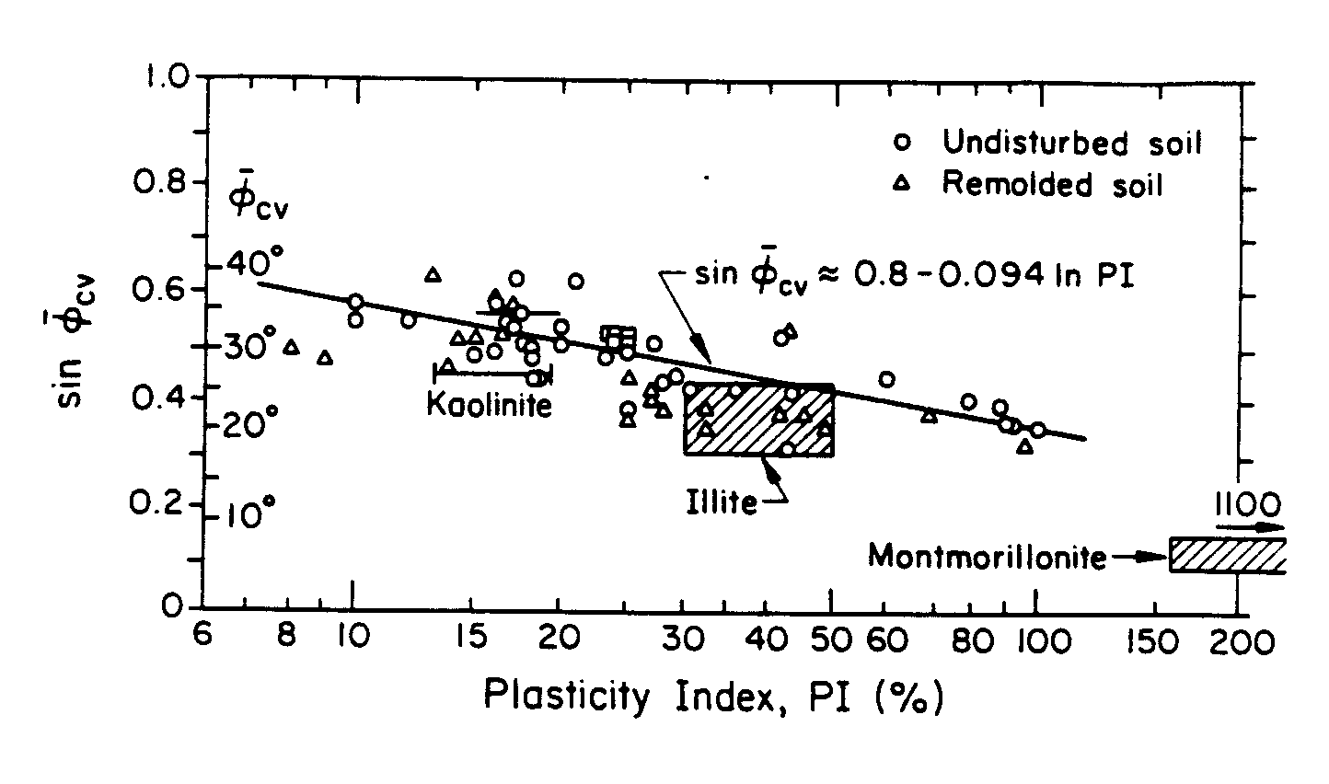

(Mitchell, 1993)

(Bolton, 1986)
Influence of Intermediate Principal Stress on Friction Angle

Introduction:  Models and soil mechanics  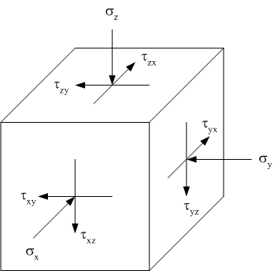
  Special conditions | Name of test | Diagram
  $$σ_{a}≠σ_{b}≠σ_{c}$$ | True triaxial | 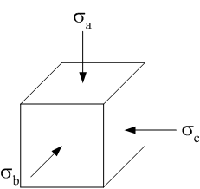
  $$σ_{b}=σ_{c}=σ_{r}$$ | Cylindrical compression  The “triaxial” test | 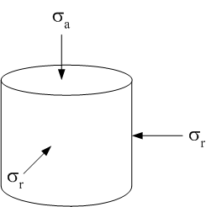
  $$ε_{b}=0$$ | Plane strain or biaxial | 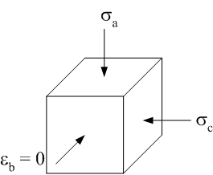
  $$σ_{b}=0$$ | Plane stress | 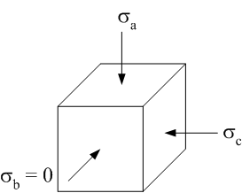
  $$ε_{b}=ε_{c}=ε_{r}=0$$ | One-dimensional compression  The oedometer test | 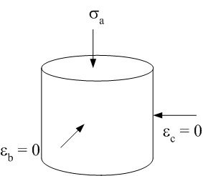
  $$σ_{b}=σ_{c}=σ_{r}=0$$ | Uniaxial compression or  Unconfined compression | 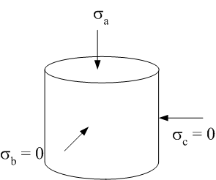
  $$σ_{a}=σ_{b}=σ_{c}=0$$ | Isotropic compression | 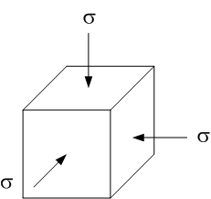

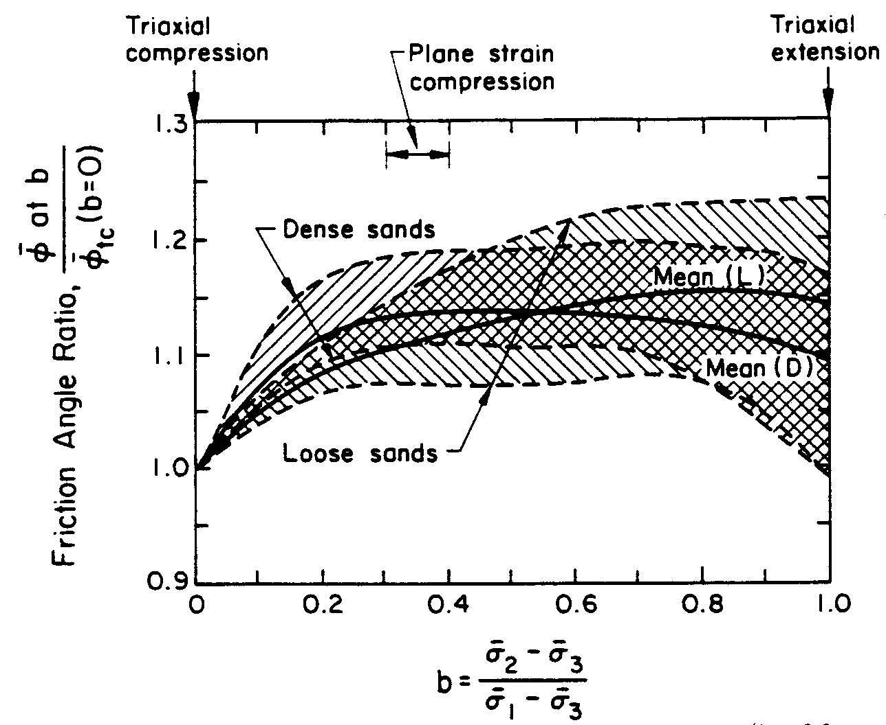
(Ladd et al., 1977)
Drained Simple Shear Test

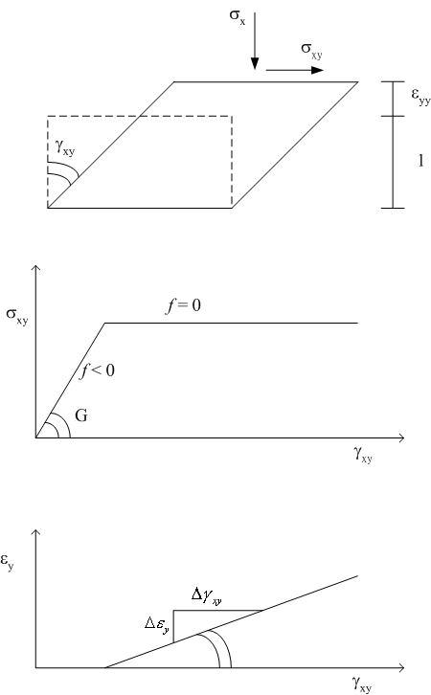
How to Understand ψ

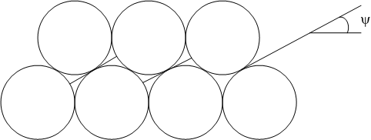

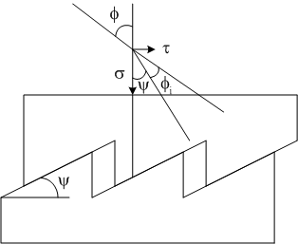

φ = ψ + φ_{i} or ψ = φ - φ_{i}
φ_{i} = inter particle angle of friction
quartz sand: ψ ≈ φ – 30º
Drained Triaxial Test

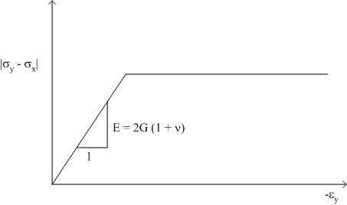

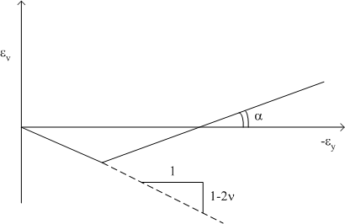

Now
(identical to biaxial test)
References

Bishop, A.W. (1966), “The Strength of Soils as Engineering Materials”, Geotechnique, Vol. 16, No. 2, pp. 89-130.

Bolton, M.D. (1986), “The Strength and Dilatancy of Sands”, Geotechnique, Vol. 36, No. 1, pp. 65-78.

Duncan, J.M and Buchignani, A.L. (1976), “An Engineering Manual for Settlement Studies”, Report, Department of Civil Engineering, University of California, Berkeley, 94 pages.

Janbu, N. (1963), “Soil Compressibility as Determined by Oedometer and Triaxial Tests”, Proc. 3rd European Conference on Soil Mechanics and Foundation Engineering, Wiesbaden, Germany, Vol. 1, pp. 19-25.

Janbu, N. (1985), “Soil Models in Offshore Engineering”, Geotechnique, Vol. 35, No. 3, pp. 241-281.

Kulhawy, F.H. and Mayne, P.W. (1990), “Manual on Estimating Soil Properties for Foundation Design”, Report EL-6800/1493-6, Electric Power Research Institute.

Ladd, C.C., Foott, R., Ishihara, K., Schlosser, F., and Poulos, H.G. (1977), “Stress-Deformation and Strength Characteristics”, Proc. 9th Int. Conference on Soil Mechanics and Foundation Engineering, Tokyo, Japan, Vol. 2, pp. 421-494.

Mitchell, J.K. (1993), “Fundamentals of Soil Behavior”, John Wiley & Sons, Inc., New York, 2nd Edition.

Naval Facilities Engineering Command, NAVFAC, “Soil Mechanics Design Manual”, DM-7, Alexandria, Virginia, 1982, 355 pages.

Pestana, J. (2001), PLAXIS Lecture Notes, Department of Civil and Environmental Engineering, University of California, Berkeley.

Wroth, C.P. and Wood, D.M. (1978), “The Correlation of Index Properties with Some Basic Engineering Properties of Soils”, Canadian Geotechnical Journal, Vol. 15, No. 2, pp. 137-145.
Appendix A

Determination of |  | from plasticity theory in drained simple shear test:

Rate of volume change:
We will proof:
At failure only plastic strains!

Hence:
Appendix B
Drained Biaxial Test

Determination of α in drained biaxial test:

+
Appendix B
Drained Biaxial Test

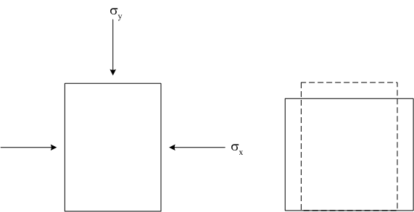

Difference with triaxial test: | Plane strain
Appendix B
Drained Biaxial Test

